**DEEPFAKE DETECTION**

Submitted in partial fulfilment of the requirements

of the degree of

Bachelor of Engineering

by

|  |  |
| --- | --- |
| Ankit Basrur | 60003170006 |
| Devansh Mehta | 60003170014 |
| Dhrumil Mehta | 60003170018 |

Guided by

Dr. Vinaya Sawant



Department of Information Technology

D. J. Sanghvi College of Engineering,

Mumbai – 400 056



**CERTIFICATE**

This is to certify that the project entitled “**Deepfake Detection”**

is a bonafide work of

|  |  |
| --- | --- |
| **Student Name** | **SAP ID** |
| **Ankit Basrur** | **60003170006** |
| **Devansh Mehta** | **60003170014** |
| **Dhrumil Mehta** | **60003170018** |

submitted to University of Mumbai as a partial fulfilment of the

requirement for the award of the degree of “**Bachelor of Engineering”** in

**“Information Technology”**

Dr. Vinaya Sawant

Internal Guide

Dr. Vinaya Sawant,

HOD IT Dept.

Dr. Hari Vasudevan,

Principal

**Project Report Approval for B.E.**

This project report entitled **Deepfake Detection** by **Ankit Basrur, Devansh Mehta, Dhrumil Mehta** is approved for the degree of Information Technology.

|  |  |
| --- | --- |
| Examiners 1 | -------------------------------------------------- |
| Examiners 2 | -------------------------------------------------- |

Date:

Place:



**Declaration**

We declare that this written submission represents our ideas in our own words and where others' ideas or words have been included, we have adequately cited and referenced the original sources. We also declare that we have adhered to all principles of academic honesty and integrity and have not misrepresented or fabricated or falsified any idea/data/fact/source in our submission. We understand that any violation of the above will be cause for disciplinary action by the Institute and can also evoke penal action from the sources which have thus not been properly cited or from whom proper permission has not been taken when needed.

|  |  |
| --- | --- |
| Ankit Basrur 60003170006 |  |
| ----------------------------------------------------- | --------------------------------------- |
| Devansh Mehta 60003170014 |  |
| ----------------------------------------------------- | -------------------------------------- |
| Dhrumil Mehta 60003170018 |  |
| ----------------------------------------------------- | -------------------------------------- |

Date:

**Acknowledgement**

We thank the management of Dwarkadas J. Sanghvi College of Engineering and our Principal Dr. Hari Vasudevan for providing us with all the facilities needed to complete the project. We would like to convey our heartfelt gratitude to our Head of Department and our project guide, Dr. Vinaya Sawant for inspiring us to take up this project. Their valuable guidance, without which, we would have never been able to complete the project, cannot be forgotten. Finally, we would like to express our gratitude for the faculty members of Information Technology Department of Dwarkadas J. Sanghvi College of Engineering and thank them for their co-operation and timely guidance. We also thank all our teaching and non-teaching staff of Information Technology Department of Dwarkadas J. Sanghvi College of Engineering for their direct or indirect help in our project work.

- Ankit Basrur, Devansh Mehta, Dhrumil Mehta

Dwarkadas J. Sanghvi College of Engineering

**Abstract**

In this ever changing world the thing that matters the most is the identity. So people uses various online tools to forge a particular image/video through the various tools available online. Deepfake creation is easily done by layman, which can be used for the defamation of an individual/organization/community. To resolve these issues ,the AI based tools, ML based tools are been used to detect the images. Recent methods, on the other hand, applies deep learning to automatically extract prominent and discriminatory features to detect deepfakes. Since it is hardly possible to stop creation of such deepfake images/videos but it is of utmost importance that this doesn’t destroy someone’s reputation . So we have proposed detecting Deepfake using XceptionNet and DenseNet for images and videos respectively.

**List of Figures**

|  |  |  |
| --- | --- | --- |
| **Figure No.** | **Figure Name** | **Page No.** |
| Figure 1 | Working of Amber | 3 |
| Figure 2 | Working of TruePic | 4 |
| Figure 3 | HOG Face Detector | 5 |
| Figure 4 | MTCNN Face Detector | 6 |
| Figure 5 | HiReST architecture | 6 |
| Figure 6 | Face Alignment using OpenCV and Python | 7 |
| Figure 7 | Aligned faces in each of the recursion HiReST | 8 |
| Figure 8 | DenseNet architecture | 9 |
| Figure 9 | XceptionNet architecture | 11 |
| Figure 10 | ResNet50 architecture | 12 |
| Figure 11 | PRNU | 13 |
| Figure 12 | Layers in Meso-4 | 14 |
| Figure 13 | RNN Network | 15 |
| Figure 14 | Input and output of each layer in CGFace | 16 |
| Figure 15 | Proposed System Architecture | 21 |
| Figure 16 | DFD Diagram | 25 |
| Figure 17 | Use Case Diagram | 26 |
| Figure 18 | Activity Diagram | 27 |
| Figure 19 | Frames captured by our website | 28 |
| Figure 20 | Implementation of Frame Extraction | 30 |
| Figure 21 | MTCNN Detecting Side Face | 30 |
| Figure 22 | Implementation of MTCNN | 31 |
| Figure 23 | Before Face Alignment | 31 |
| Figure 24 | After Face Alignment | 31 |
| Figure 25 | Implementation of Face Alignment | 32 |
| Figure 26 | Importing required libraries | 33 |
| Figure 27 | Mounting Dataset and specifying metrics | 33 |
| Figure 28 | Training Dataset | 34 |
| Figure 29 | Testing Dataset | 35 |
| Figure 30 | Importing Pre-trained XceptionNet | 35 |
| Figure 31 | Model creation | 36 |
| Figure 32 | Specifying checkpoint and early stopping | 37 |
| Figure 33 | Training epochs | 37 |
| Figure 34 | Output | 38 |
| Figure 35 | Mounting drive | 38 |
| Figure 36 | Adding layers | 39 |
| Figure 37 | DenseNet epochs | 39 |
| Figure 38 | Freezing and unfreezing nodes | 40 |
| Figure 39 | Results | 40 |
| Figure 40 | Home Page | 41 |
| Figure 41 | Invalid Input Page | 42 |
| Figure 42 | Output Page | 42 |
| Figure 43 | Output page 2 | 43 |
| Figure 44 | Analysis page 1 | 43 |
| Figure 45 | Analysis page 2 | 44 |
| Figure 46 | Analysis page 3 | 44 |
| Figure 47 | XceptionNet Result | 58 |
| Figure 48 | DenseNet Result | 58 |

**List of Tables**

|  |  |  |
| --- | --- | --- |
| **Table No.** | **Table Name** | **Page No.** |
| 1 | Comparison of Face Detection libraries |  |
| 1 | Comparing Existing Systems with proposed model | 17 |
| 2 | Review on techniques used in various research paper | 18 |
| 3 | Task Network Diagram | 21 |
| 4 | Task Network Diagram Breakdown | 21 |
| 5 | Variables used in COCOMO Estimation | 23 |
| 6 | Effort and Development Time Estimation | 24 |
| 7 | RMM Table | 24 |
| 8 | Review on techniques used in various research paper | 38 |
| 9 | Items to be tested | 46 |
| 10 | Test Schedule | 48 |
| 11 | Integration Testing | 49 |
| 12 | Performance Testing | 50 |
| 13 | Functionality testing | 51 |
| 14 | Unit testing of face detection | 52 |
| 15 | Unit testing of detection model1 | 53 |
| 16 | User Interface Testing | 54 |

**Table of Contents**

1. Introduction 1

1.1. Motivation 1

1.2. Major Challenges 1

1.3. Report Outline 1

2. Literature Review 3

2.1. Existing Work 3

2.1.1. Literature Related to Existing Systems 3

2.1.2. Literature Related to Methodology 4

2.1.3. Literature Related to Algorithms 9

2.1.4. Literature Related to Frameworks 16

2.2. Observations on Existing Work 17

3. Proposed Methodology 19

3.1. Problem Definition 19

3.2. Scope 19

3.2.1. Assumptions and Constraints 19

3.3. Proposed Approach 20

3.3.1. Features of Proposed System 20

4. Project Management 21

4.1. Project Schedule 21

4.1.1. Task Network Diagram 21

4.1.2. Timeline Chart 21

4.2. Feasibility Study 21

4.2.1. Technical Feasibility 22

4.2.2. Operational Feasibility 22

4.2.3. Economic Feasibility 22

4.3. Project Resources 22

4.3.1. Hardware Requirements 22

4.3.2. Software Requirements 22

4.4. Project Estimation 23

4.4.1. COCOMO Estimation Model 23

4.5. Risk Management Mitigation Planning 24

5. System Design 25

5.1. Design Diagrams 25

5.1.1. DFD 25

5.1.2. UML Diagrams 26

6. Implementation 28

6.1. Working of System 28

6.2. Algorithms used 28

6.3. Interface Design 30

7. Testing and Results 32

8. Conclusion 33

9. Future Scope 34

10. Research Paper 35

References 40

# Introduction

## Motivation

The increasing growth of mobile camera technology and social media have creation and sharing of images and videos more convenient. The number of fake images as well as videos are increasing due to high level of editing tools available on Internet. The time required in manipulation of the data available to the person has decreased significantly due to Deepfake creation tools which are easily available. The knowledge of ML and computer vision decreases the manual steps required for image or video editing. This has led to an increase in spreading replicated images and videos. Deepfakes are synthetic media in which a person in an existing image or video is replaced with someone else's likeness. Thus, there is an urgent need for the detection of Deepfakes as more and more intuitive algorithms are coming for creation of Deepfake thus resulting in fall in accuracy in the detection phase.

## Major Challenges

* Classifying the input and giving the result in minimal amount of time.
* High computation power required.
* Maintaining accuracy between low quality, high quality and raw input.

## Outline of Report

**Literature Review** describes our literature review of Literature Related to Existing Systems, Literature Related to Methodologyies and Literature Related to Algorithms that can be used in project. It also includes comparison between algorithms and existing systems.

**Proposed Methodology** describes Assumptions and Constraints taken into account, Proposed Approach and the Features of Proposed System.

**Project Management** deals with the Project Schedule, Feasibility Study and Project Resources used in project. It also covers COCOMO Estimation Model used for estimation of our project and Risk Management Mitigation Planning.

**System Design** includes the DFDand UML Diagrams such as Use Case Diagram and Activity Diagram for users to know the flow of project.

**Implementation** describes the Working of System, Algorithms used in our system and Interface Design of our project. Examples of each implemented module is described.

**Experimental Results** emphasis on the Experimental Results obtained by comparing diverse methodologies and technologies which was helpful in understanding the fundamentals and can be helpful in improving results.

**Conclusion** concludes the report mentioning the importance of this project and final technologies, tools, methodologies that were implemented in this project.

**Future Scope** mentions the features and functionalities that can be included in this project in future.

**Research Paper** has the attached research paper in a format that has been submitted in IJERT journal and IEEE Gucon 2021.

# Literature Review

## Existing Work

### Literature Related to Existing Systems

* **Amber:** Amber creates video using by hashing the clips ate source and storing it in blockchain which can be useful for tracking the chain of custody. They have also used detecting splicing artifacts using Neural Network that can detect when a content is added to a video using ResNet and algorithms for finding out facial discrepancies and camera specific signatures and misalignments in color filter array and anomalies in gradients but also detecting post-processing of face swaps which includes Blur Detection and Color Matching. It can be used only on iOS and supports only video detection. A small subscription fee is also charged by the vendor [1].

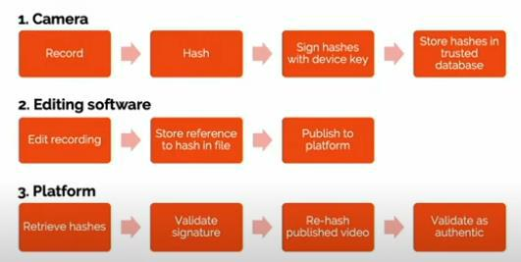

Figure Working of Amber

* **TruePic:** It is mainly focussed on object verification but the same principle can be used for deepfakes as well. It verifies critical metadata at the point of capture with the one received. It uses blockchain as well as AI to detect manipulations in metadata or objects. It is limited to only those who subscribe to their application and charges fee once the trial is over. It supports both images as well as for videos [2].

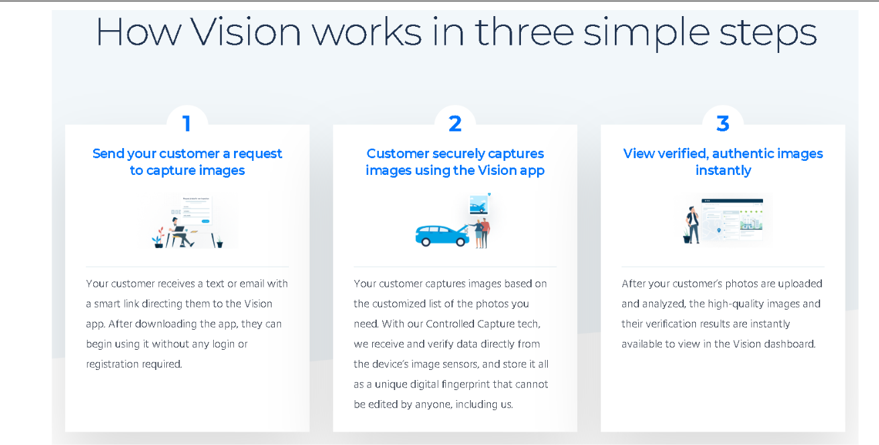

Figure Working of TruePic

### Literature Related to Methodology

The video is divided into frames and face detection and alignment is performed on both, images and frames from videos. The scaling of images such that every face can be aligned with same y-coordinates of eyes. It is common step for both images and videos.

#### **Face Detection**

##### **HOG face detector using Dlib**

The Histogram of Oriented Gradients (HOG), which transforms image pixels into a vector representation that is sensitive to broadly informative image features regardless of confounding factors like illumination. HOG face detection is based on Sliding Window Classifier.

The model is trained using following steps:

1. Collect the training dataset: The first stage is to collect the HOG represented images.
2. Train a model: Build a classifier model to classify there is a face or not in the image using all the HOG represented images for training the model.
3. Detect the face: Sliding Window Classifier works on it. It slides on the entire image until it returns true and detects the position of the image.

Coding for it:

1. Importing PIL and Face Detection libraries:

PIL is an open source Python image library that allow you to open, manipulate and save the different image file formats. It used to easily display the image and draw a line on the top of the image. Face recognition library will give you access to use the face detection model. Thus, it relieves from building own face detection model for finding the faces in the photograph.

1. Load the Image into the Numpy array: As we need to get the location of the faces
2. Find all the faces in the photograph
3. Draw the rectangular shape: Converting the image to the PIL Image using the fromarray () method and using the PIL Draw () method.

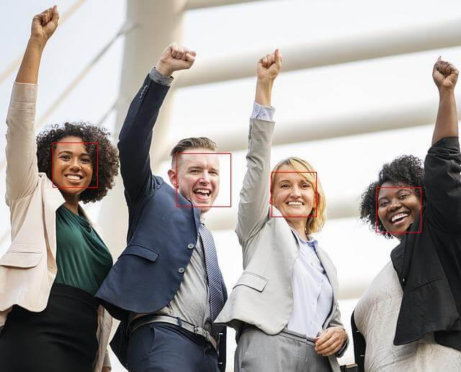

Figure HOG Face Detector

HOG and CNN both are used to detect the face. The only difference is their accuracy. Deep Learning (Convolutional Neural Network) method is more accurate than HOG, but it requires high computational power like High GPU, CPU, etc. as compared to HOG [3].

##### **Multi-task Cascade Convolutional Neural Network (MTCNN)**

MTCNN consists of 3 stages, which detects the bounding boxes of faces in an image along with 5 features of facial landmarks. Each stage passes its inputs to a CNN. Bounding boxes with scores are returned. MTCNN can detect side faces whereas HOG was unable to do so.

The input image is scaled down and is passed through CNN. Image extraction is performed for each bounding box and resize them (**24x24**and **48x48** for phase 2 and phase 3, respectively) and are forwarded to CNN. Stage 3 additionally computes 5 features of facial landmarks along with the confidence value [4] .

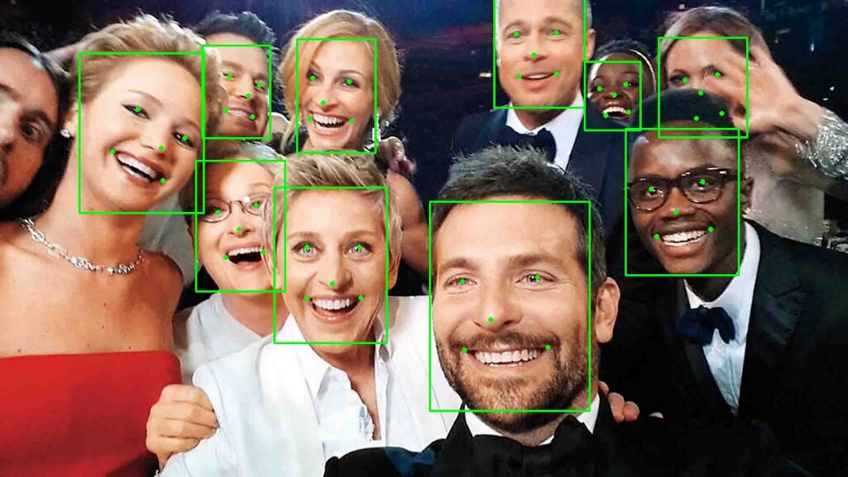

Figure MTCNN Face Detector

##### **Recursive Spatial Transformer (ReST)**

It can be used for Face detection and Alignment. The detected face can be transformed to a new one by optimizing an affine transformation using ReST model. From a frame, the ReST model transforms it recursively to make it easier to recognise a face. In each recursion, based on previously transformed face, a transformation is generated to get to the optimal one.

To model non-linear variations, Hierarchical ReST (HiReST) is an extension to ReST. In HiReST, a face is divided and are used with a ReST which is used to determine rigid area along with its alteration parameters [5].

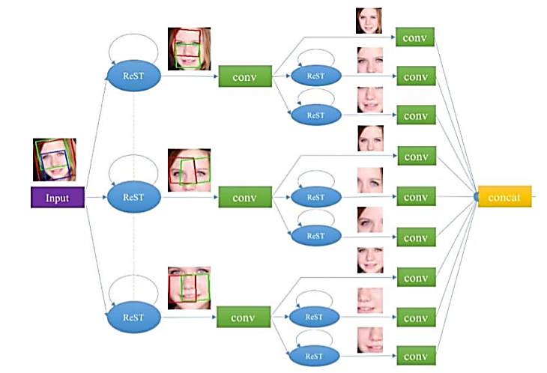

Figure HiReST architecture

##### **OpenCV DNN with Caffe models**

We need two sets of files for implementing the Caffe models for deep learning:

1. .prototxt file which defines the model architecture (i.e. the layers themselves)

2. .caffemodel file which contains the weight for the actual layers

OpenCV’s deep learning face detector is based on the Single Shot Detector (SSD) framework with a ResNet base network.

Steps included for detecting the images:

1. Constructing the argument parser: We require 3 arguments viz., --image (path of the image), --prototxt (path of the Caffe prototxt file) and –model (path of pretrained Caffe model).
2. Loading the image and resizing it to 300x300 pixels
3. Passing it to network and obtain detection and prediction
4. Drawing boxes over the detected faces.

To increase the brightness, we can use Histogram Equalization or CLAHE [6]

The issue over here is cropping the face and aligning it to pass it to our model is not a part of this process. [7]

#### **Face Alignment**

1. **OpenCV**

We had to use face alignment to reduce training differences so that our model trains faster and also improve efficiency. Basically, face alignment using OpenCV follows certain steps [8]:

First step is to detect a face and eyes after which centre of eyes is found. Connecting those two points and forming a right-angled triangle will help us in finding the angle. Last step is rotating the image by that angle.

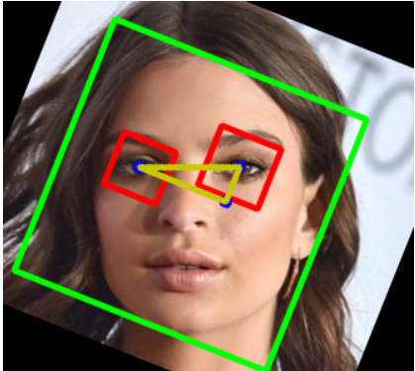

Figure Face Alignment using OpenCV and Python

1. **ReST**

As discussed previously in the previous Section C. ReST is used for alignment as well. Here the face is first divided using various facial features automatically and then the features are passed to convolutional network followed by concatenating the proper aligned face.

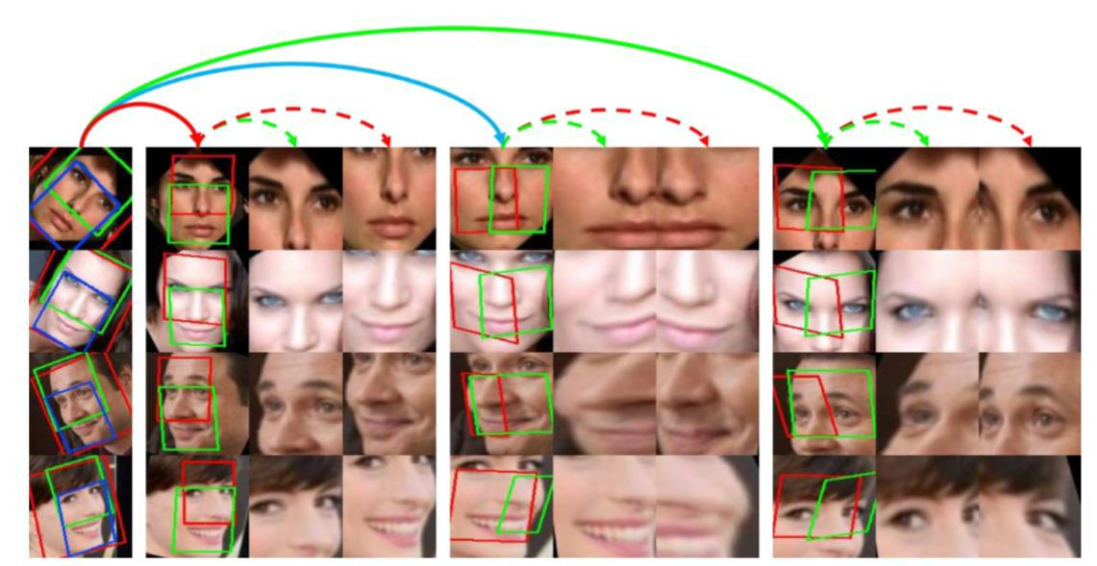

Figure Aligned faces in each of the recursion HiReST

### Literature Related to Algorithms

#### **DenseNet**

#### It is used to extract features at different layers in a network. In this model, each layer can access loss function of the previous layer and the original video signal which helps in improving efficiency. It then concatenates features learned from each layer. Densenet architecture uses of three direction feature extraction: a down-sampling path which is used for extracting coarse semantic features, followed by an up-sampling path to recover the input image resolution at the output of the model and, optionally, a post-processing module to refine the model predictions. At the end of layer, we get a spatiotemporal matrix which consists of features detected from each layer. After face detection, N faces will be obtained and will be sent to network. For learning spatiotemporal information, DenseConvLSTM is employed. Regardless of the results which are obtained, the features can be passed to next structure using Concat. 3D DenseNet is employed for spatiotemporal information fusion. Each convolution block has 3 different layers which connects to ConvLSTM block. It contains two bi-directional LSTM. Using DenseNet architecture with 3D convolutions, all features will be aligned [9].

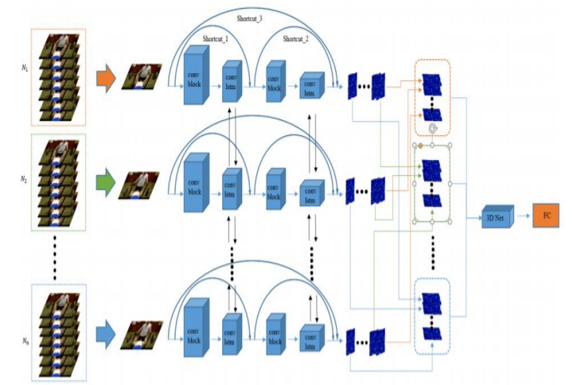

Figure DenseNet architecture

In Figure 8 DenseNet architecture, a whole video will be split into N frames, each section containing the same number of video frames and then randomly samples a frame from each subset to represent the entire subset. Since there are a lot of duplicate frames in whole video, it is very wasteful to send the whole video into the network for calculation, and it will get a lot of repeated useless information. By this method, redundant information can be avoided and useful information can be extracted, and spatiotemporal information of video can be extracted effectively through repeated random sampling iteration in training.

After sampling, N frames will be obtained and will be sent to network. The network has two main components, the first is the DenseConvLSTM, and this part is used for learning simple spatiotemporal information. And second is the 3D DenseNet, this part is for high dimensional spatiotemporal information fusion. Concat is also used in the DenseConvLSTM block, which means that the original information can be passed on to the next structure irrespective of whether the results of the feature are good or not.

It is necessary to extract the features of video using the convolution block before bi-direction ConvLSTM. Each convolution block has three different convolution layers, and connect to ConvLSTM block to learn spatiotemporal features. ConvLSTM consists of two bi-direction LSTM. All features will be re-stacked using DenseNet architecture with 3D convolutions.

DenseNet is a network that portrays the importance of having dense connections in a network using dense blocks. This helps in feature-reuse, better gradient flow, reduced parameter count and better transmission of features across the network. Such an implementation can help in training deeper networks using less computational resources and with better results. All these good properties make DenseNet a natural fit for per-pixel prediction problems [9].

#### **XceptionNet**

Xception is an extension to Inception. It makes use of a pre-trained ResNet18 model on ImageNet, and move the weights is for learning features that are more beneficial for detection i.e. objects, skin colour alteration, distortion, etc. It makes the model to look for more useful features.

Unlike other models where a FC classifier is utilized for facial highlights extraction by ResNet18. For example, eyes or ears, that would just retain certain faces which are linked with the label name “real” while others are linked with the name “fake”. ResNet18 is customized so that it looks for other artifacts such as distortion or discrepancies in a face to detect deepfake, hence can overcome the problems discussed earlier. Due to this, classifier can generalize better for new and untrained deepfakes. Also, classifier architecture which has one or more dense layers are used in place of ResNet18, with hidden activations [10].

Drawbacks: This model cannot detect unique forgery like Neural Textures, as it is not trained on those samples.

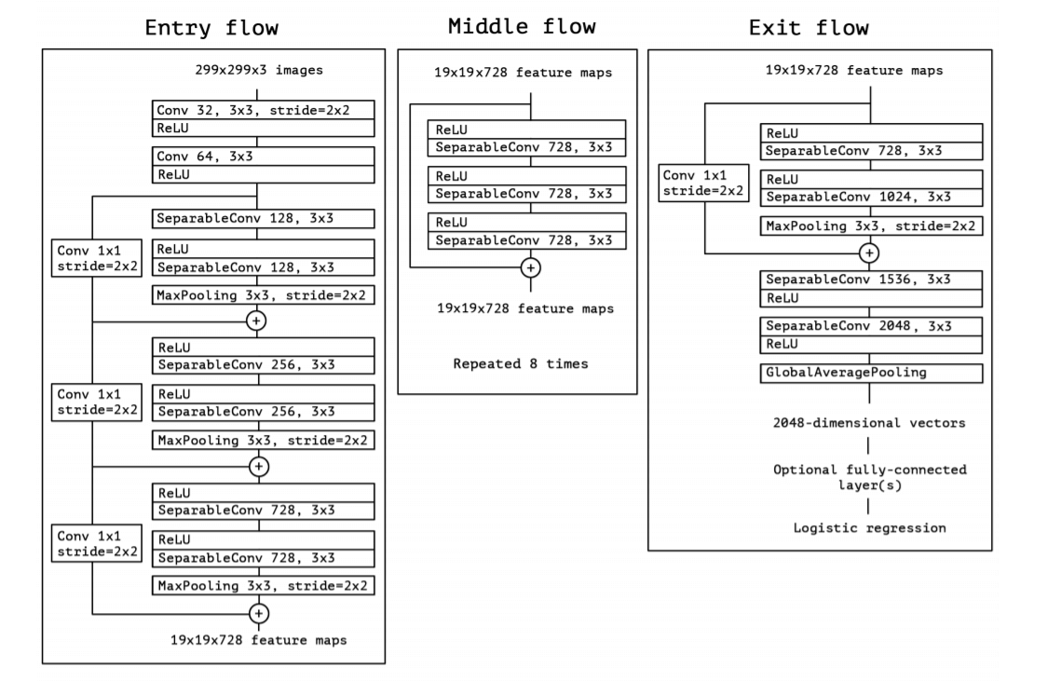

Figure XceptionNet architecture

#### **ResNet**

Using a CNN model, comparison is made between the generated face areas and their surrounding regions. ResNet is a customized CNN architecture. ResNet50 is commonly used as it can detect deepfakes better than MesoNet [11]. Align the detected faces into multiple scales and randomly pick one scale, which is then smoothed by a Gaussian blur with kernel size (5 X 5). This aides in improving the resolution. The face undergoes an affine warp to the same sizes of original faces to simulate the artifacts in the DeepFake production pipeline.

To add variety to the training dataset, variations in illumination, contrast, alteration and sharpness for all training examples are made, which can be distinguished by the pipeline [11].

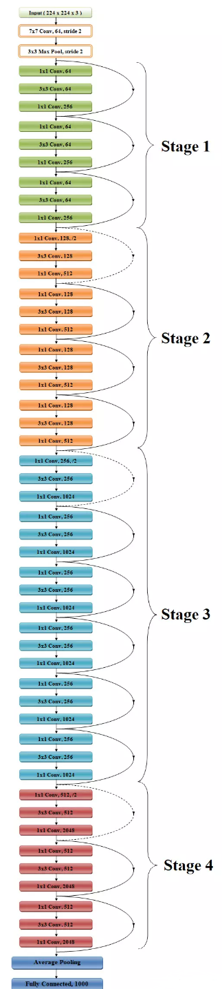

Figure ResNet50 architecture

In order to solve the problem of the vanishing/exploding gradient, this architecture introduced the concept called Residual Network. In this network we use a technique called skip connections.

Drawback: The accuracy of this model decreases once 1200 layers are used up.

#### **2.1.3.4. PRNU**

Gyfcat is used to spot inconsistencies in the facial area of an uploaded video. When the detection model marks a video suspicious, a facial mask is generated to check whether a video exists with the same body and background. If it exists, but the faces of the original and the newly uploaded video do not match, then the software concludes that the new video has been manipulated.

The videos are turned into a series of frames as PNGs with the use of the software ’FFmpeg’, named sequentially, and kept in labelled folders. In order to increase the significance of the expected change in PRNU pattern in the facial area of the frame, the frames will be cropped to frame the face, also with the use of ’FFmpeg’. Each frame of a video is cropped by the exact same pixels in order to leave the portion of the PRNU pattern which is examined consistent between each cropped frame.

The frames are then sequentially divided into eight groups of equal size, with the software ’PRNUCompare’ These eight PRNU patterns are then compared to one another, and normalised cross correlation scores are returned. The variations in correlation scores and the average correlation score for each video are calculated. A Welch’s t-test will be applied to the results in order to assess the statistical significance between the results for Deepfakes and for authentic videos.

The mean normalised cross correlation scores per video and the variance in normalised cross correlation scores per video are calculated. A significantly lower score indicated the video has been subjected to manipulations [12].

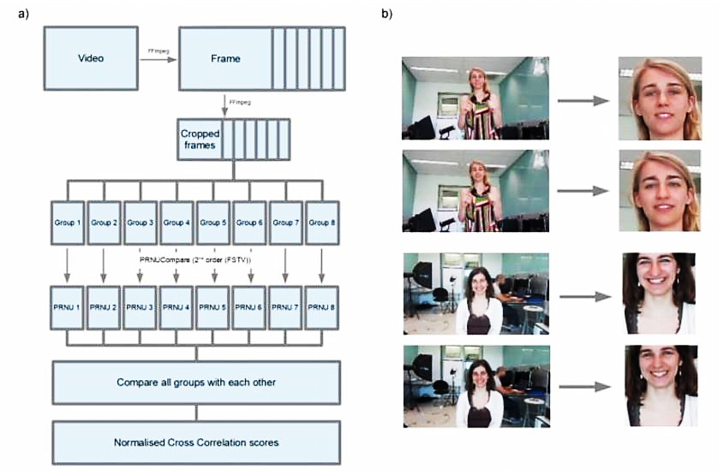

Figure PRNU

Drawback:It requires large databases of videos from which it can compare between the videos.

#### **Meso-4**

For dataset it uses two computer graphics-based approaches (Face2Face and FaceSwap) and two learning-based approaches (DeepFakes and NeuralTextures). All four methods require source and target actor pairs as input. It is a CNN-based network used to detect face tampering in videos.

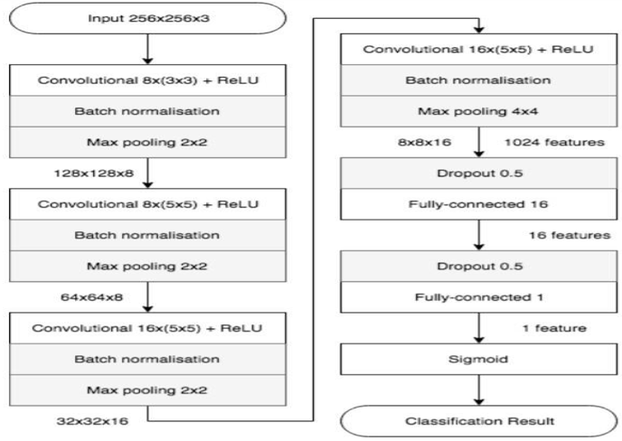

Figure Layers in Meso-4

It consists of a sequence of four layers of successive convolutions and pooling, and then a dense network is used which has a hidden layer. The convolutional layers use ReLU activation functions that introduce non-linearities and Batch Normalization is used to regularize their output and prevent the vanishing effect, and then fully-connected layers use Dropout of 0.5 to regularize and improve their robustness. We get a sigmoid function whose output ranges from 0 to 1 based on which we can tell whether it is deepfake or not [13].

#### **RNN**

A recurrent neural network (RNN) is a class of [artificial neural networks](https://en.wikipedia.org/wiki/Artificial_neural_network) where connections between nodes form a [directed graph](https://en.wikipedia.org/wiki/Directed_graph) along a temporal sequence. This allows it to exhibit temporal dynamic behaviour. Derived from [feedforward neural networks,](https://en.wikipedia.org/wiki/Feedforward_neural_networks) RNNs can use their internal state (memory) to process variable length sequences of inputs.

A two-stage analysis composed of a CNN to extract features at the frame level followed by a temporally-aware RNN network to capture temporal inconsistencies between frames introduced by the face-swapping process.

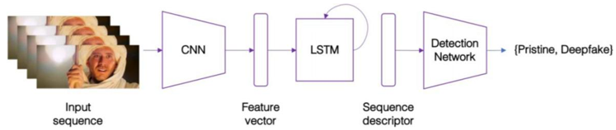

Figure RNN Network

The proposed system is composed by a convolutional LSTM structure for processing frame sequences. There are two essential components in a convolutional LSTM:

* **CNN**

It is used for frame feature extraction. Using the InceptionV3 with the fully-connected layer at the top of the network removed to directly output a deep representation of each frame using the ImageNet pre-trained model. Following, we do not fine-tune the network. The 2048-dimensional feature vectors after the last pooling layers are then used as the sequential LSTM input.

* **LSTM**

It is used for temporal sequence analysis. A sequence of CNN feature vector of input frames as input and a 2-node neural network with the probabilities of the sequence being part of a deepfake video or an untampered video. The key challenge that we need to address is the design of a model to recursively process a sequence in a meaningful manner. For this problem, we resort to the use of a 2048-wide LSTM unit with 0.5 chance of dropout [14].

The CGFace model is a customized CNN model as common CNN model does not give promising results when the model is trained using a set of facial features and the testing dataset contains different facial features. They have used 5 convolutional layers and the input size to this model is 64x64 grayscale images.

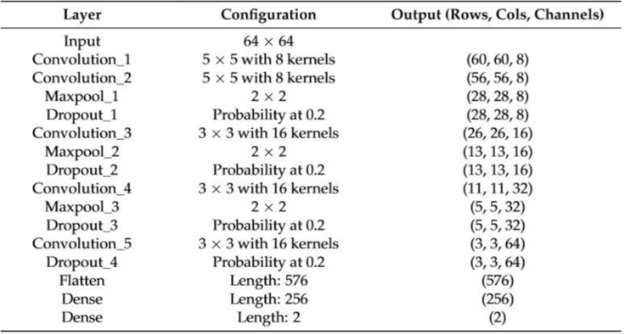

Figure Input and output of each layer in CGFace

Convolution preserves the relationship between pixels by learning image features using small squares of input data. Increasing the no. of convolutional layers will increase the learned features complexity. These layer uses a set of learnable kernels sliding across the image to extract features. ReLU function was applied on activation layer because it had higher fitting abilities. The pooling layer is placed after the convolutional layer to reduce the parameters and prevent over fitting problem. The output feature map of the convolutional layer is fed to Pooling layer and for each block a max pooling algorithm is applied to reduce the parameters and it produces a single output. After chain of convolutional and pooling layers, a one-by-two vector is passed to the fully generated layers. It is then passed to a softmax classifier [15].

### Literature Related to Frameworks

#### **Keras**

* Keras is an open-source neural-network library written in Python. It is capable of running on top of TensorFlow. It is designed to enable fast experimentation with deep neural networks.
* Keras is an API designed for human beings, not machines. [Keras follows best](https://blog.keras.io/user-experience-design-for-apis.html) [practices for reducing cognitive load](https://blog.keras.io/user-experience-design-for-apis.html) as it offers consistent & simple APIs and minimizes the number of user actions required for common use cases thus providing clear and actionable feedback upon user error.
* In order to use DSSIM loss function which is implemented based on Keras library – is used to reconstruct face.
* Keras-VGGFace is a classifier used for face verification and identification.

#### **PyTorch**

* PyTorch is a free and open source machine learning library based on the Torch library, used for applications such as computer vision and natural language processing.
* Training model becomes somewhat difficult as some network are not provided as they are in Keras (pre-trained models).
* Understanding forward pass and backward becomes easier in PyTorch.
  + - 1. **MxNet**
* Apache MxNet is an open-source deep learning software framework, used to train, and deploy deep neural networks.

• MXNet is significantly faster, much more memory-efficient and more accurate than Tensorflow**.**

* MxNet’s ImageRecordIter and RecordIO will be used to process and record features extracted pin every frame.

## Observations:

Table Comparison of Face Detection libraries

|  |  |  |  |  |  |  |  |
| --- | --- | --- | --- | --- | --- | --- | --- |
| **Sr. No** | **Model name** | **Method** | **Bounding Box Shape** | **Time** | **Recall** | **Precision** | **Downsides** |
| 1 | HOG | Sliding window classifier | Square | Least | 82.6% | 95.24% | Bounding box always a square which leads to over highlightening of region.  Cannot detect non-frontal faces |
| 2 | MTCNN | Cascade of Neural Networks | Arbitrary rectangle | Highest | 89.85% | 98.02% | Consist of 3 neural networks thus takes more time. |
| 3 | ReST | Face is divided into multiple regions and each region is subjected to classification. | Arbitrary rectangle | Moderate | 89.24% | 98.63% | Cannot detect non-frontal faces |

Table Comparing Existing Systems with proposed model

|  |  |  |  |
| --- | --- | --- | --- |
| **Parameters** | Amber [1] | TruePic [2] | Proposed System |
|  |  |  |  |
| **Technologies used** | Blockchain & AI | Blockchain & AI | AI |
|  |  |  |  |
| **Used for** | Videos | Images & Videos | Images & Videos |
|  |  |  |  |
| **Free to use** | No | No | Yes |
|  |  |  |  |
| **Runs on** | iOS | Mobile & Desktop | Desktop |
|  |  |  |  |

Table Review on techniques used in various research paper

|  |  |  |  |  |
| --- | --- | --- | --- | --- |
| **Sr. no.** | **Paper name** | **Dataset** | **Algorithm** | **Type** |
| 1 | Detection of Face Morphing Attacks by Deep Learning [16] | ILSVRC dataset 9000 fake images | VGG-19, GoogleNet | Images |
| 2 | Face X-ray for More General Face Forgery Detection [17] | FaceForensics++ having 1000 videos (Real and fake) | Face X-ray | Images |
| 3 | On the Detection of Digital Face Manipulation [18] | Video dataset from FaceForensics++, FaceAPP images from StyleGAN and PGGAN | Xceptionet | Images and videos |
| 4 | Deep Learning Based Computer-Generated Face Identification Using Convolutional Neural Network [19] | PCGAN and BEGAN dataset | CGFace (customized CNN) | Images |
| 5 | FaceForensics++: Learning to Detect Manipulated Facial Images [13] | Dataset provided by Google and JigSaw | Xceptionnet | Images and videos |
| 6 | Recurrent Convolutional Strategies for Face Manipulation Detection in Videos [20] | FaceForencsice++ dataset 1000 videos (Real and fake) | RCN and DenseNet | Videos |
| 7 | Detection of Deepfake Video Manipulation [12] | Custom made dataset | PRNU | Videos |
| 8 | Deep Learning with Depthwise Separable Convolutions [10] | Xceptionet ImageNet and JFT (Google dataset) | XceptionNet | Images |

# Proposed Methodology

## Problem Definition

Every day, vast amounts of multimedia content is generated through a variety of devices and shared via social media, newspaper, and television. Among them, images and videos play a crucial role regarding communication because it is considered one of the most influential communication media, which dominates most social network sites, mostly because existing mobile devices allow people to capture high-quality images anywhere at any time. Unfortunately, we cannot fully trust digital images as before since advancements in computer technology has led to the creation of manipulations where one can superimpose face images of a target person to a video of a source person to create a video of the target person doing or saying things the source person does. These techniques were aimed to create defamation of the person and to spread misleading information. These techniques weren’t so common until nowadays where anyone with little or no technical knowledge can create such manipulations. Even popular social app like Snapchat has been using techniques to swap faces between two people. As a result, there is an urgent need to use the right technique to exploit all the discrepancies between the authentic and the fake ones. By addressing this problem, it is possible to stop misleading information from the source by integrating it with social media like Facebook.

## Scope

This project aims to develop and implement a Deepfake detection system with an objective of classifying images and videos being authentic or fake ones. Our system can be used in social media platforms and also by government agencies since most Deepfakes are based on them.

### Assumptions and Constraints

* In this project, we aim to create a website for Deepfake detection system since mobile applications are not equipped to carry such high load task.
* The size of the video or image should be less than specified limit (For a video, time taken to detect can vary since it takes 5 minutes for 15 sec video).
* The end-user has high end computer.
* Video with no face cannot be detected since our model focuses on detecting face morphing.
* Unable to detect source where the video was created.

## Proposed Approach

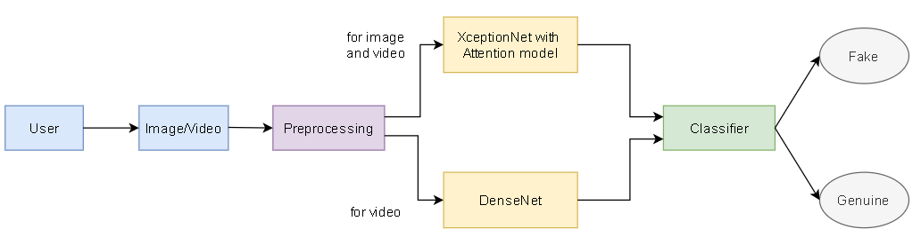

Figure Proposed System Architecture

### Features of Proposed System

* **Pre-processing**: Initially, if the input is video then it is broken down into frames based on predefined frame rate and then it is converted into greyscale and then MTCNN is used for face detection. Face alignment is applied using OpenCV so that eye level will be the same for all the frames which will be helpful for training the model. Lastly, the input is scaled so as to fit it into the detection model.
* **DenseNet**: This is a pretrained model which needs to be fine-tuned with our dataset. Since each layer receives an input from all previous layers, it makes feature propagation better and also reduces the parameters.
* **XceptionNet**: It is a traditional CNN trained on ImageNet based on separable convolutions with residual connections. In this technique we transfer it to our task by replacing the final fully connected layer with two outputs.
* **Attention Based Model:** This model was introduced for Natural Language Processing (NLP) tasks. It gives attention to several salient feature, which will be passed ahead in the network. It is the most suitable model since it will highlight the region that has discrepancies in it, rather than focusing on entire image. This will help to learn salient features and it will eventually increase accuracy and speed.
* **Classifier**: SoftMax can be used as binary classifier to classify whether an image is fake or genuine.

# Project Management

## Project Schedule

### Task Network Diagram

Table Task Network Diagram

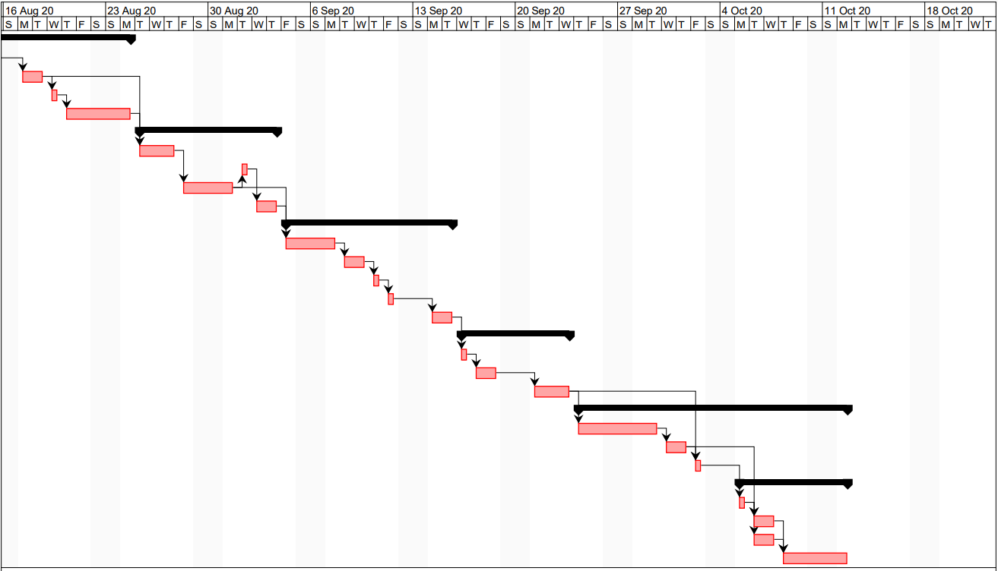

### Timeline Chart

Table Task Network Diagram Breakdown

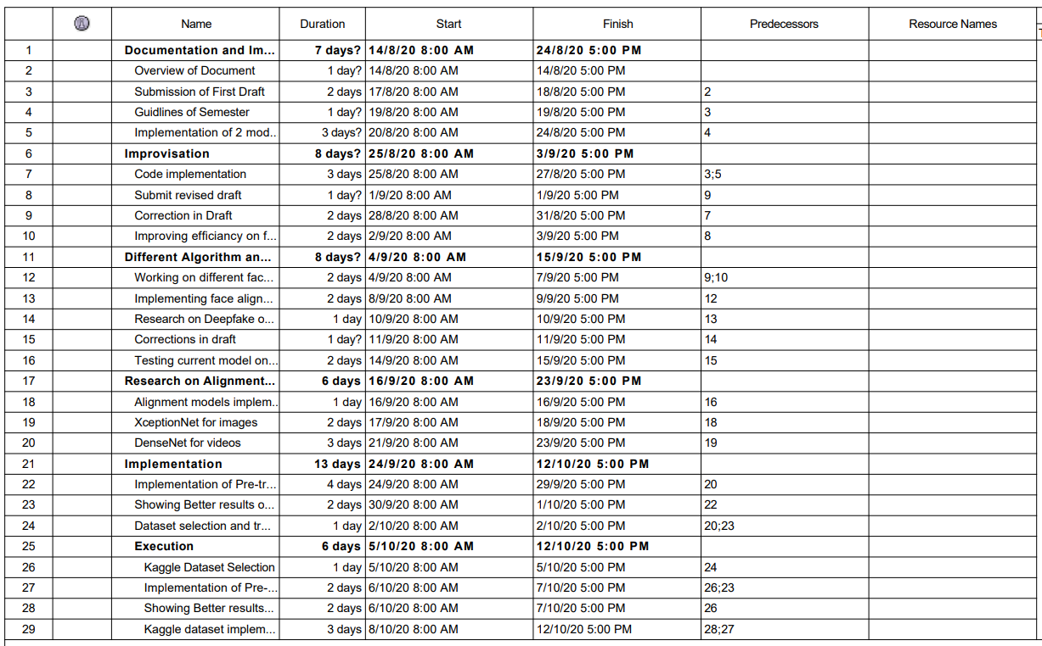

## Feasibility Study

### Technical Feasibility

* **Dataset**

For improvising the results of our software, we need to have low as well as high quality videos. The training model will learn effectively if the data which is to be trained is vast. This problem is solved using Kaggle and Diverse Fake Faces Dataset (DFFD). Kaggle has 470GB of videos and DFFD contains 1.8M fake images and 0.8M real images.

* **Computation**

This can be resolved by using cloud for computation and algorithm which we will be using will aim to reduce the time and increase the accuracy. Hence technical feasibility is obtained.

### Operational Feasibility

Users do not need to learn new skills for using our project. User can interact with the system effortlessly. It can be used by an organization and common people. Since many fake videos are being generated, this project will help to address that issue. The project will be able to cater any new change and unforeseen problems which might arise later. Hence operational feasibility is obtained.

### Economic Feasibility

In the project the hardware requirements are minimal which helps in cost effectiveness. It has great scope in domain and can be used in large scale in future. We may need to use AWS for computation, the cost of which is $1.902 per Hour. Since our project is built on open source technology it does not require any subscription or license.

## Project Resources

### Hardware Requirements

* 8GB RAM
* 10GB HDD
* Intel Core i5-7200U CPU 2.50GHz

### Software Requirements

* Windows 10
* Python 3.6.3

## Project Estimation

### COCOMO Estimation Model

Basic COCOMO computes software development effort and cost), as function of program size. Program size is expressed in estimated thousands of source lines of code (SLOC. KLOC).

COCOMO applies to three classes of software projects:

* Organic projects - "small" teams with "good" experience working with "less than rigid" requirements.
* Semi-detached projects- "medium" teams with mixed experience working with a mix of rigid and less than rigid requirements.
* Embedded projects -developed within a set of "tight" constraints. It is also combination of organic and semi-detached projects. (Hardware, software, operational...).

The basic COCOMO equations take the form:

* Effort Applied (E) – ab​ (KLOC)​bb ​ [​ person-months].
* Development Time (D) = cb​ (​ Effort Applied) db ​ [​ months].
* People required (P) - Effort Applied / Development Time (count).
* KLOC is the estimated number of delivered lines (expressed in thousands) of code for project.

The coefficients ab, bb, cb and db are given in the following table:

Table Variables used in COCOMO Estimation

|  |  |  |  |  |
| --- | --- | --- | --- | --- |
| **Software Project** | **ab** | **bb** | **cb** | **db** |
| Organic | 2.4 | 1.05 | 2.5 | 0.38 |
| Semi-detached | 3.0 | 1.12 | 2.5 | 0.35 |
| Embedded | 3.6 | 1.20 | 2.5 | 0.32 |

Table Effort and Development Time Estimation

|  |  |  |
| --- | --- | --- |
|  | **Effort (PM) = ab * (kloc) ^ bb** | **Development Time(months) = cb * (Effort) ^ db** |
| **Organic** | E= 2.4 * (1.85) ^ 1.05 = 4.57 | T = 2.5 * (4.57) ^ 0.38 = 4.45 |

Effort = 4.57 Person

Months’ Time = 4.45 Months

## Risk Management Mitigation Planning

Table RMM Table

|  |  |  |  |
| --- | --- | --- | --- |
| **Risk Event** | **Effect** | **Mitigation** | **Contingency Plan** |
| Load on browser | Unstable system behaviour resulting in browser crash. | Test prototype | Restart the browser |
| Failure in data format after pre-processing. | Prediction accuracy drops. | Try various testing conditions | Ensuring uniformity in frames. |
| Video length too large or too many faces to detect. | Waiting time increases resulting in browser crash. | Test prototype and set video length limit | Break the video |
| Server freezing | System failure | Test prototype | Restart the server |

The following risks exist in our system:

* **Load on browser:** It can lead to unstable system behaviour and ultimately the browser crashes. Try restarting the browser.
* **Wrong data format after pre-processing:** Prediction accuracy drops. By trying various testing conditions, we can ensure uniformity in frames.
* **Video length too large or too many faces to detect:** It can lead to increase in waiting time resulting in browser crash. We can prevent this by breaking the video.
* **Server freezing:** It leads to system failure. Try restarting the server.

# System Design

## Design Diagrams

### DFD

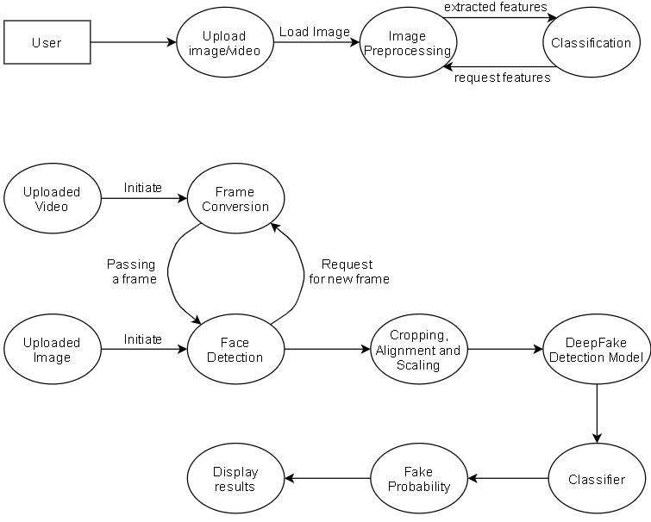

Figure DFD Diagram

In this diagram , the end user will upload a/an video/image in to the system for checking if the uploaded file is real or fake , the diagram is than further been drilled down to level 1 to make it look more simple, while checking for videos it may break down the videos into various frames and the algorithm applied for it may check for variations in the face in each frame , and will request for different frames after checking the previous one , after converting it to frames it, will align the face and crop the face with exact coordinates and it will check whether it is fake or not by giving the probability of it being a fake video , and will display the results to the user after passing on through model and classifier models. For images, it will directly be passed on alignment model and will pass on through classifier and detection model, for the deepfake detection.

### UML Diagrams

#### **Use Case Diagram**

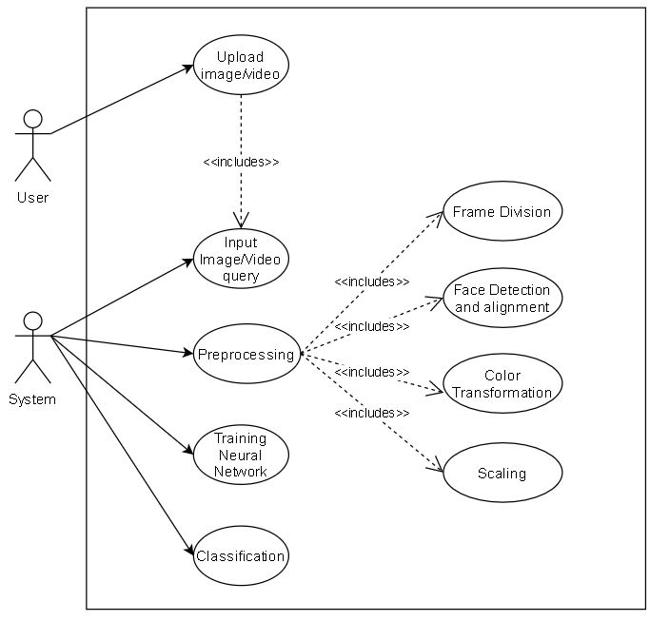

Figure Use Case Diagram

In this diagram the user uploads a file consisting of a video or an image, then the system accepts the file and will go under the pre-processing where face alignment model will come into picture. After the alignment the Image will be tested for fake detection where it will then be checked for color transformation and we have used grayscale so that if there are any anomalies then it will give us the result whether the person’s image is fake or not.

#### **Activity Diagram**

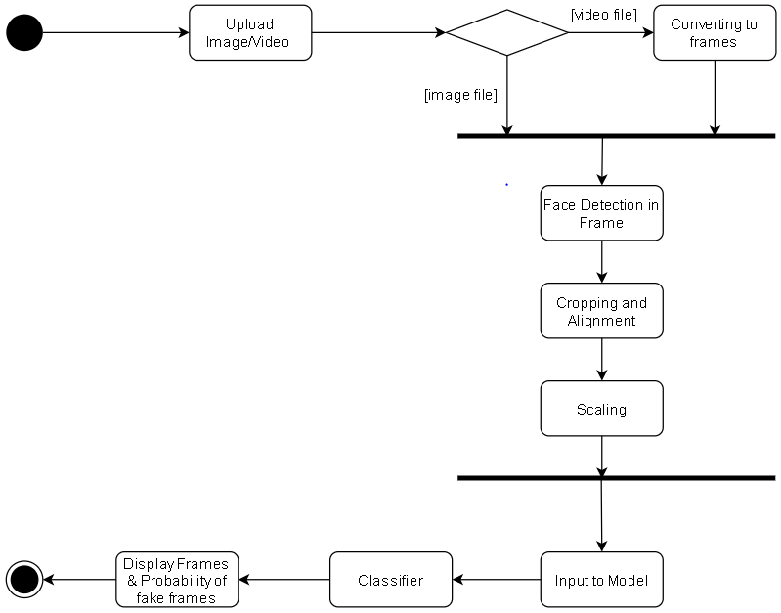

Figure Activity Diagram

User will upload a video or an image the system will take it as an input , so if it is a video then it will be broken down to many frames on which face alignment model will be applied and later using the coordinates it will mark the face and will go through the classifier and at the end will give us the probability whether the image/video is fake or not.

# Implementation

**Dataset:** The dataset that has been used has 18,000 images which are classified into two folders, train and valid; and in each there are two classes i.e., fake and real. It has 12000 images for training and 6000 for validation. It is a part of DFFD dataset.

## Working of System

The working of the model is explained in Proposed Approach.

## Algorithms used

* **Frame extraction**: We have used OpenCV for frame extraction where we have specified the frame rate as 5 fps. This step is exclusively for videos only.

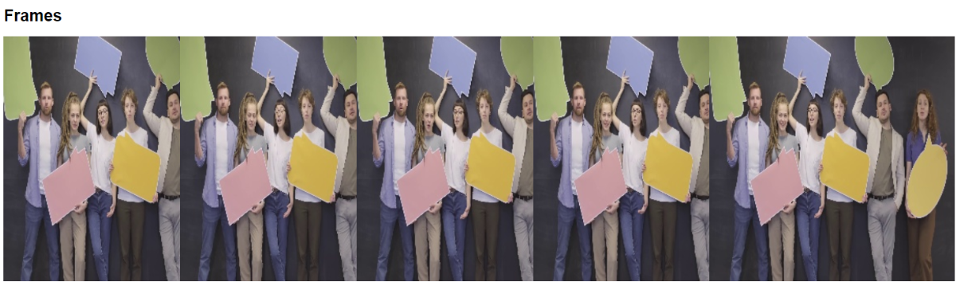

Figure Frames captured by our website

**Implementation:**

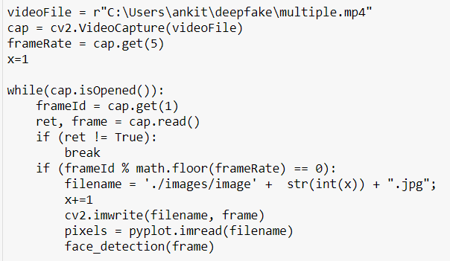

Figure Implementation of Frame Extraction

We load the input video and for every 5th frame we are applying our MTCNN model. We are storing the given input and frames into our local machines to retrieve it later when the user wants to see detailed report. Lastly, we pass the frames to the face detection model.

* **Face detection**: We have implemented MTCNN for face detection. This module can detect side faces and also gives 5 features of the detected face i.e. coordinates of eye, nose confidence value etc. It can also detect multiple faces in a given frame.

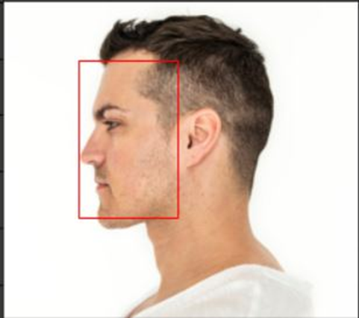

Figure MTCNN Detecting Side Face

In this example, we have successfully found out all the side face in the given image using MTCNN.

**Implementation:**

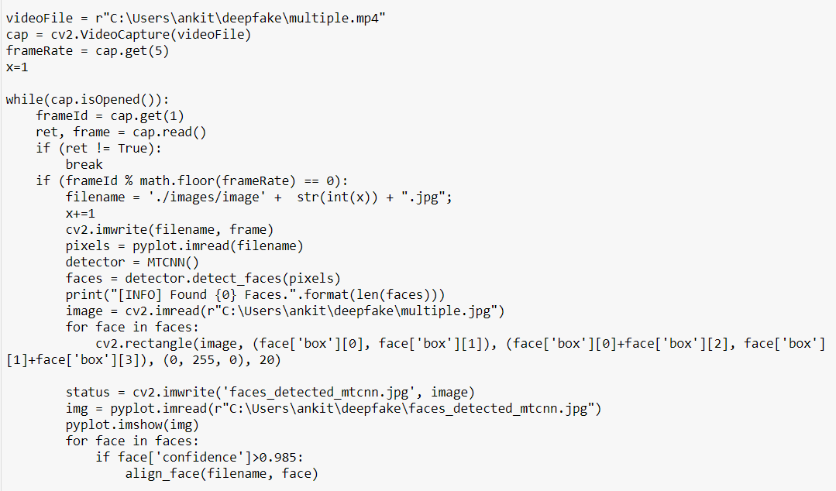

Figure Implementation of MTCNN

Here, we are using MTCNN for face detection. We are drawing a box around each face whenever a given face has over 98.5% confidence rate as we have found lower value gives high rate of detecting false positive output.

* **Face alignment**: This step is required to reduce the differences that might exist in faces so that our model can train faster and improve efficiency.

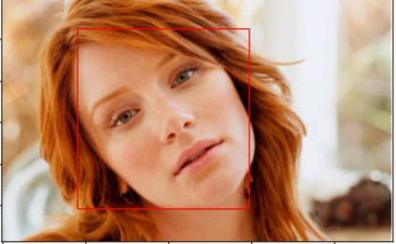

Figure Before Face Alignment

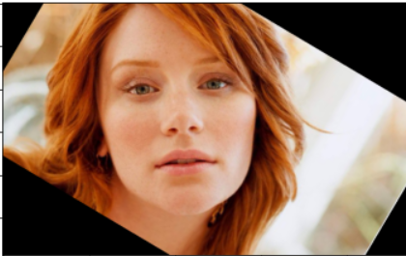

Figure After Face Alignment

Here, our goal is to have the person’s face aligned in a way that both the eyes are at the same level.

**Implementation:**

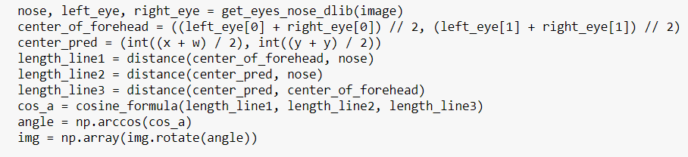

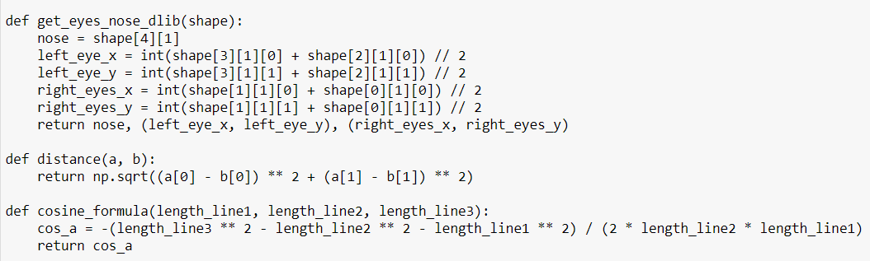

Figure Implementation of Face Alignment

In face alignment, we detect coordinates of eyes, nose and then find the centre of the face. The next step is to form a triangle and calculating distance between two eyes and the forehead. Finally we rotate the face using OpenCV with the cosine of the distance between the triangle formed.

* **Face resizing and conversion**: Here, we convert the aligned face to 299x299 and to grayscale to minimise inconsistencies and then transfer it to the model prediction.
* **Model prediction**: For prediction we have used XceptionNet with attention model. This model looks for inconsistency in the face region and highlights it.

**Implementation:**

**Step 1:** TensorFlow library is used to design this model. Keras.model.sequential model of the TensorFlow library is used since it has layer sharing and allows non-linear topology e.g. residual connections.

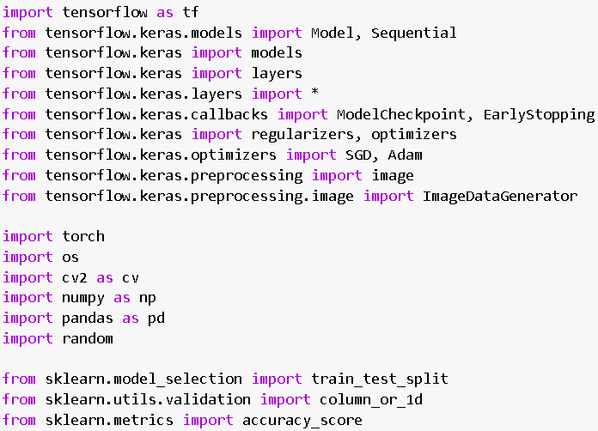

Figure Importing required libraries

**Step 2:** Loading data from drive and processing it using Keras.preprocessing library. Training and validation dataset are generated and loaded with fill mode as nearest with batch size as 32.

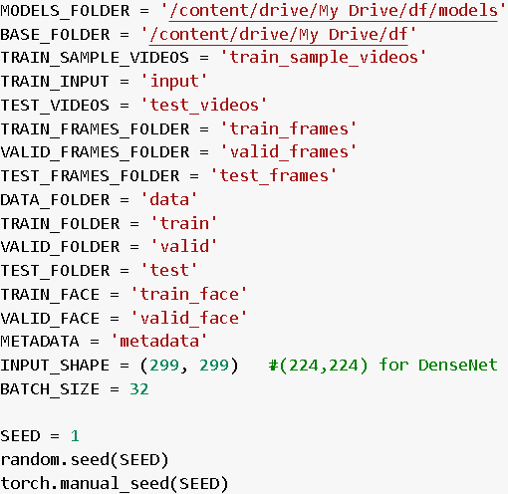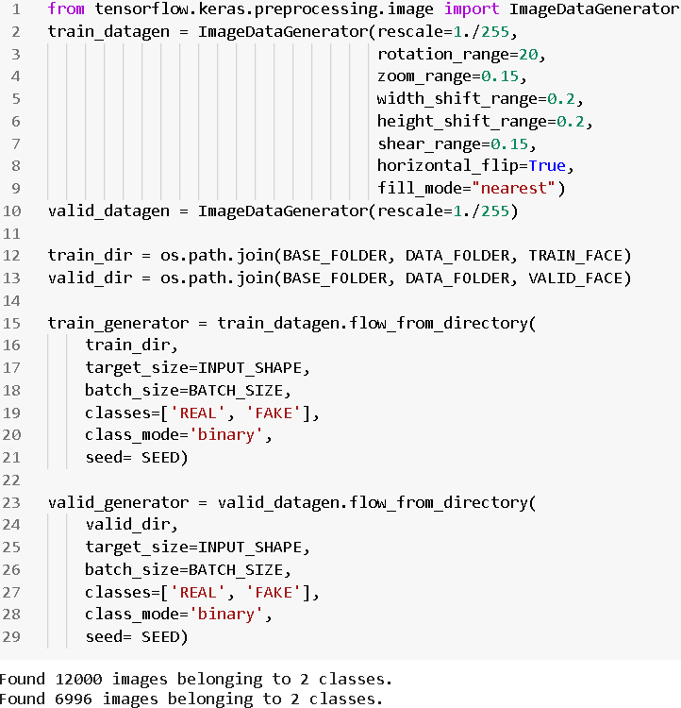

Figure Mounting Dataset and specifying metrics

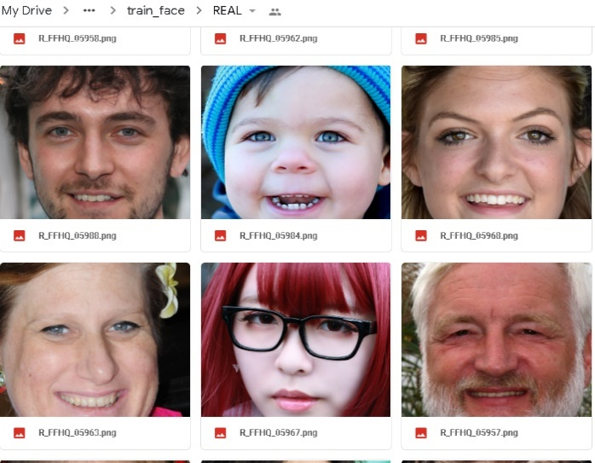**Step 3: 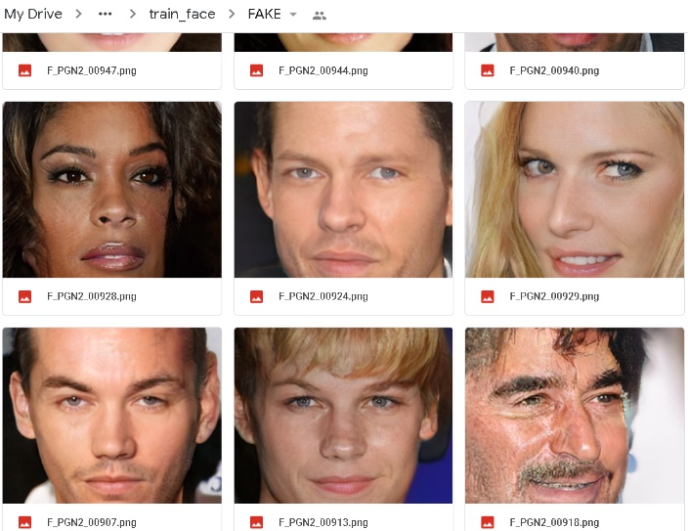Training dataset**

Figure Training Dataset

**Testing Dataset:**

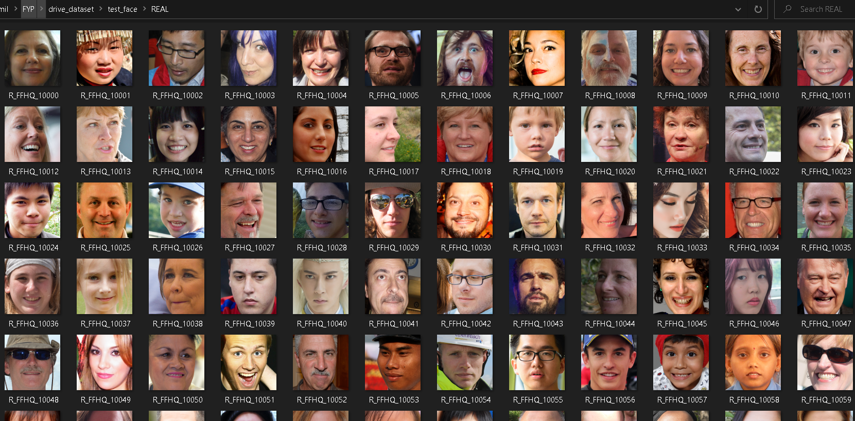

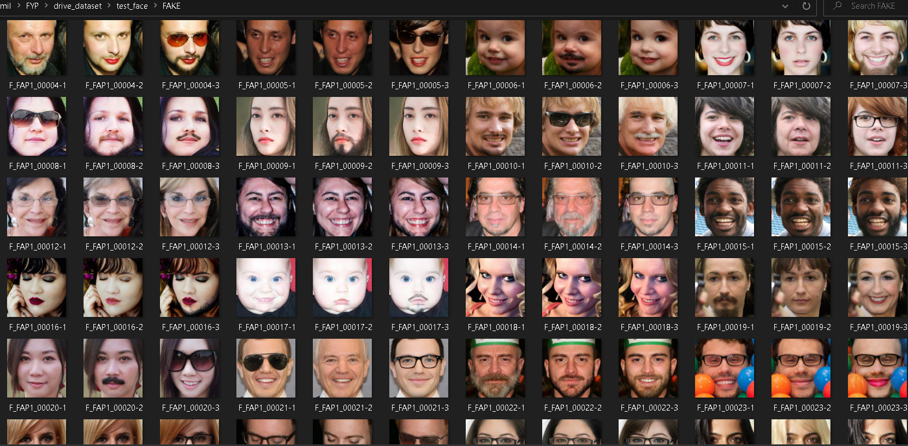

Figure Testing Dataset

**Step 4: Create a model**

1. **XceptionNet:** The pretrained weights on ImageNet dataset is loaded with the help of keras.applications.xception. In Attention Mechanism, feature input and batch normalization layers are then added followed with 4 Convolutional and pooling layer, to turn pixels to GAP. Then we fan it out to all the channels, using up_c2_w. To account missing values from attention model we rescale it using gap_features and gap_mask. We then add attention mechanism to our base XceptionNet with Adam Optimizer, 1e-3 learning rate and binary cross entropy as loss function.



Figure Importing Pre-trained XceptionNet

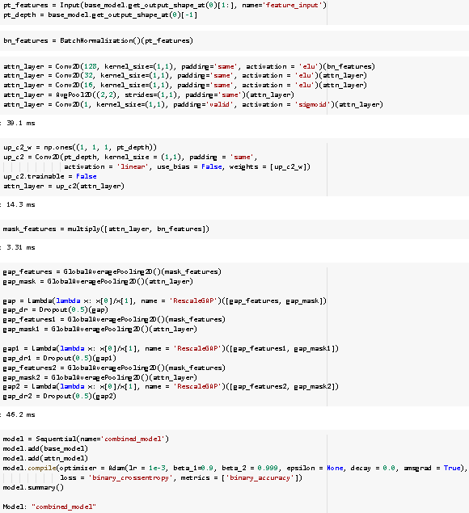

Figure Model creation

Checkpoint loss and accuracy callbacks are used with the help of Keras.callbacks. Early stopping condition with patience = 3 is implemented to avoid overfitting.

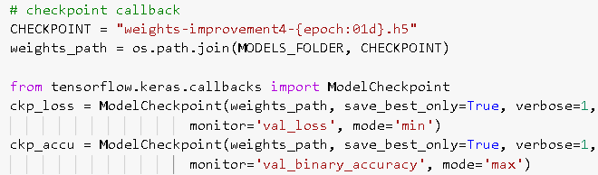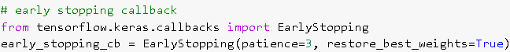

Figure Specifying checkpoint and early stopping

Training model: We have trained it for 15 epochs. This snapshot displays the training done for last 5 epochs.

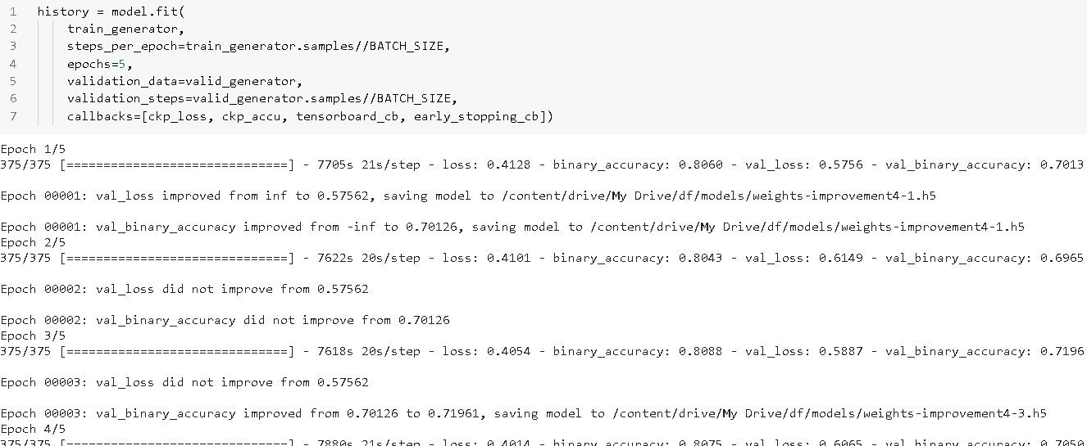

Figure Training epochs

**Output:**

From the graph below, we can see the training accuracy is around 81% and validation accuracy is 73%. Training loss is around 40% and validation loss is around 58%.

Figure Output

1. **DenseNet:** The preprocessing step remains the same for DenseNet except for the input size of the image to be (224,224) instead of (299,299). Initially, the pretrained weights are loaded. We have stacked series of Pooling, BatchNormalization and Dropout layer on top of base model. Adam Optimizer with learning rate 5e-4 and binary cross entropy loss function to compile our model.

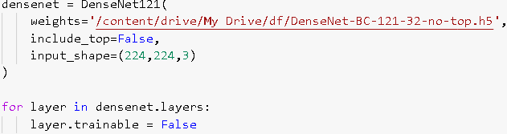

Figure Mounting drive

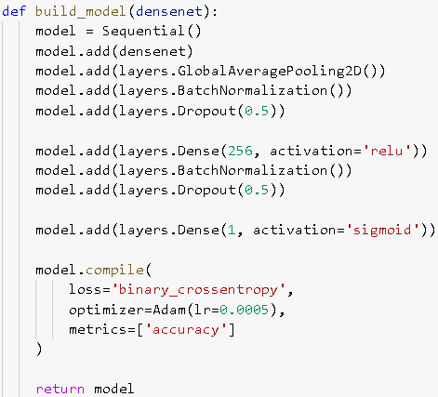

Figure Adding layers

We have then freeze the initial layers for 10 epochs to reduce the training time. Later, we unfreeze and train it all for 5 epochs.

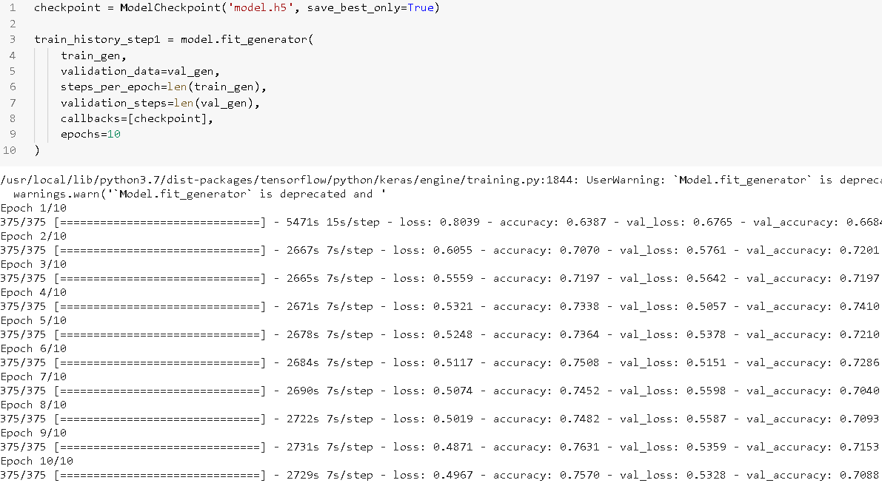

Figure DenseNet epochs

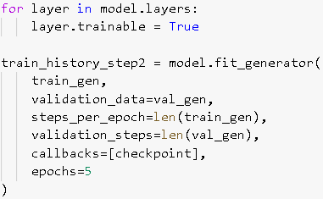

Figure Freezing and unfreezing nodes

**Results:**

From the graph below, we can see the training accuracy is around 77% and validation accuracy is 71%. Training loss is around 48% and validation loss is around 52%.

Figure Results

* **Classifier**: Softmax is used as binary classifier between real and fake input.

## Interface Design

* **Home Page**

Our interface is designed using ReactJS. Here the user can either upload an image or video which would be pre-processed and then sent for the prediction model.

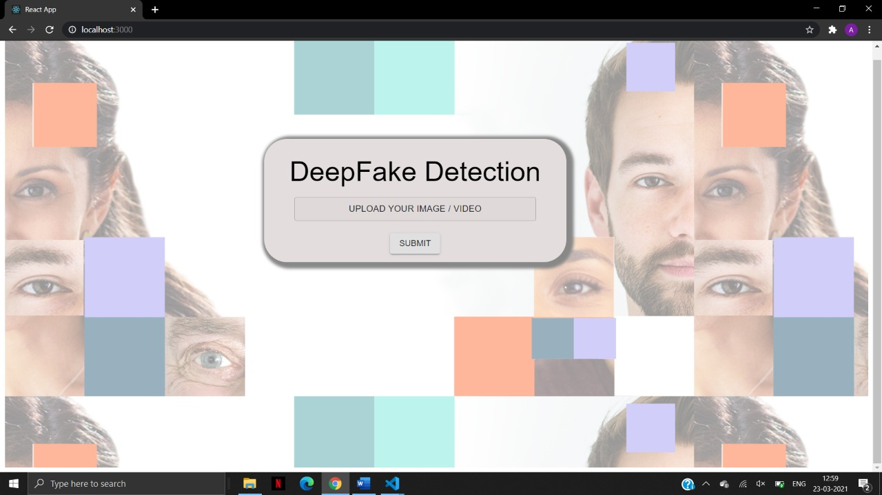

Figure Home Page

* **Intermediate Page**

The image/video file is uploaded by the user and if the size of the file is not adequate/permissible than the file will not be tested and it will give error and then the user may have to upload proper file.

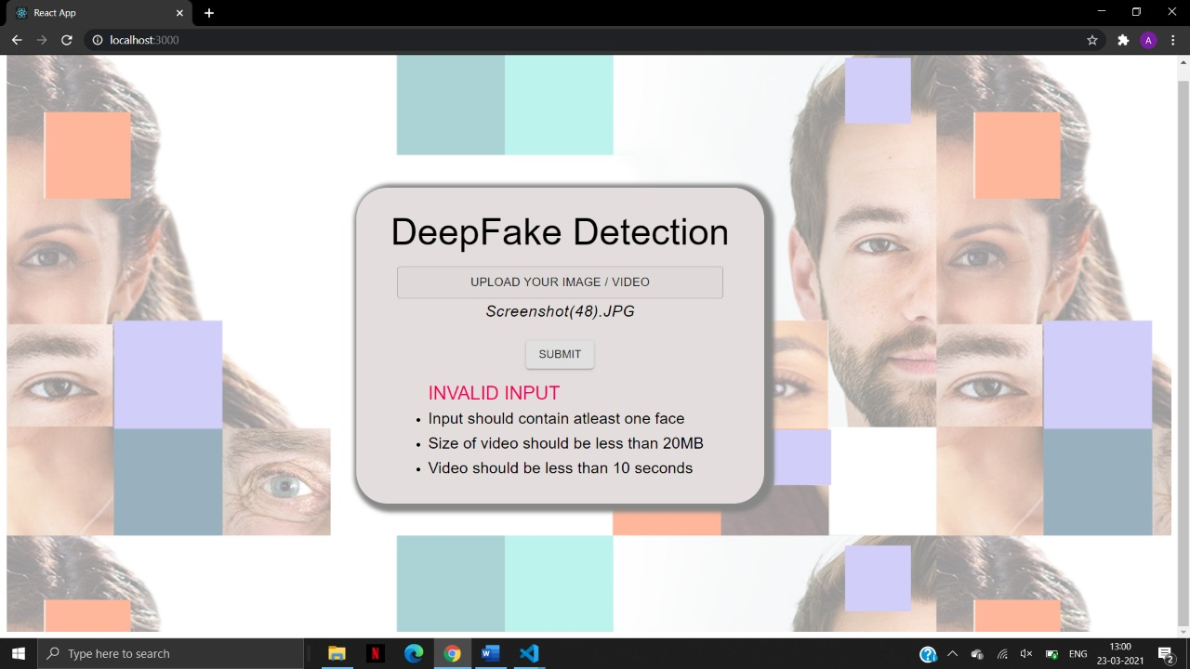

Figure Invalid Input Page

When the file is uploaded the result will be given after testing and then in this case the image is perfectly real .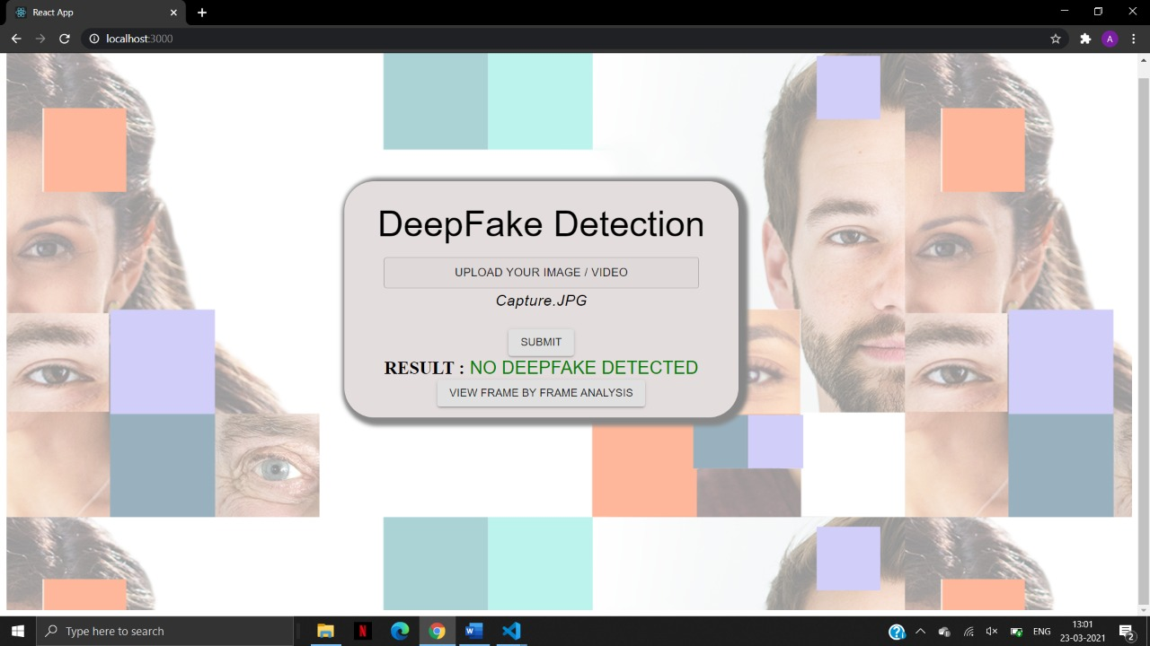

Figure Output Page

After uploading the file the system will take a while to work on the uploaded image/video file and then it will give the result whether the image is fake or not , In this case the image is

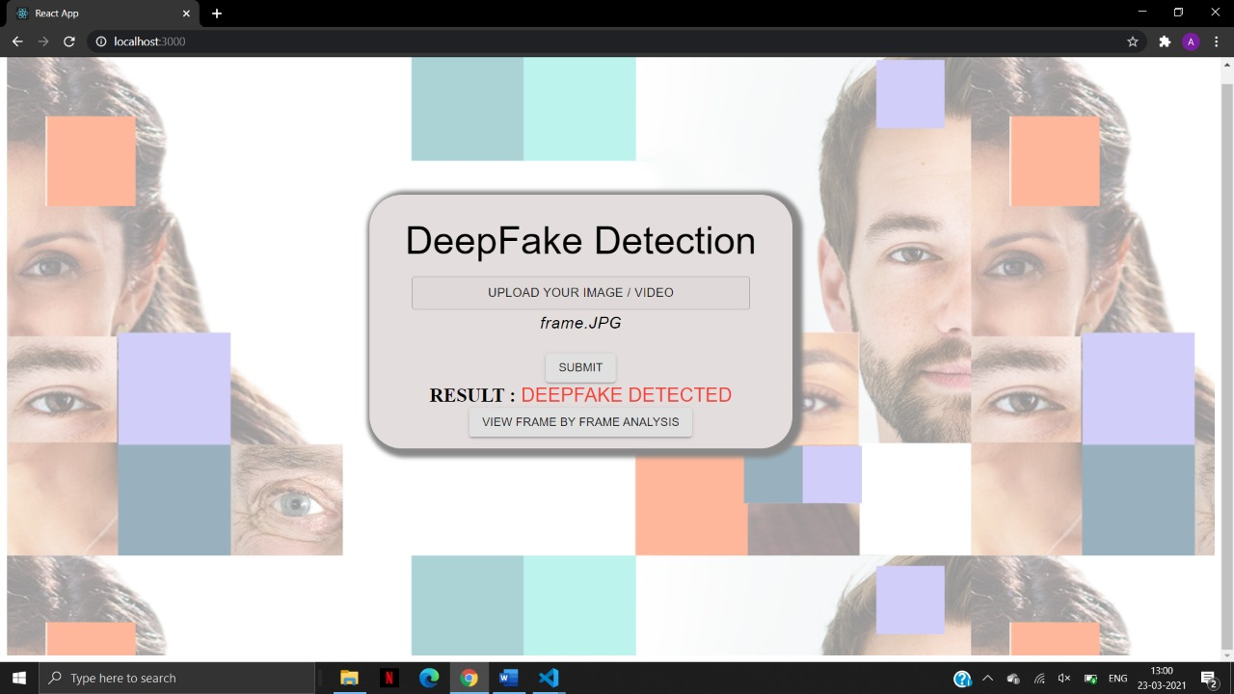

Figure Output page 2

* **Results Page:**

In this image as we can see that one particular image has 6 faces and by using the XceptionNet algorithm, has detected 6 images and cropping each face it will align each face and will go through the classifier process.

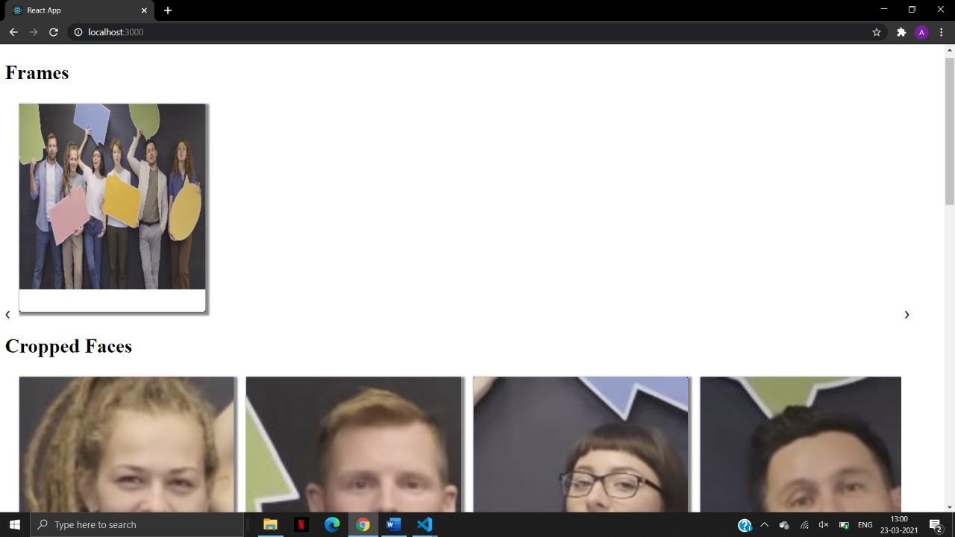

Figure Analysis page 1

After detection the 6 faces are been tested individually and then each photo will be aligned parallely with both eyes at same level and then it will give the results expected

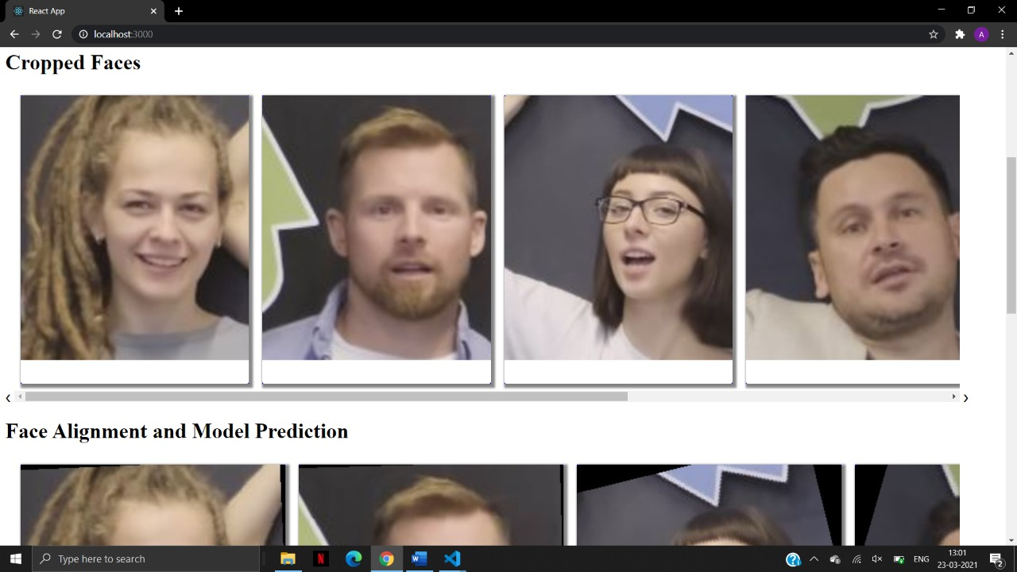

Figure Analysis page 2

In this figure the image is broken down into various frames of each person and then the image has gone through the XceptionNet algorithm and after classifying the image has been found as it is fake and it is shown in the figure by giving the fake probability .

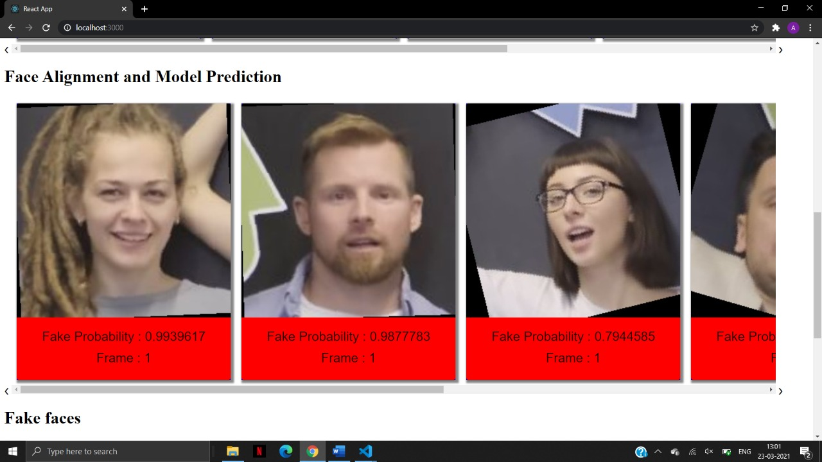

Figure Analysis page 3

1. Testing and Results

**Test Plan:** Testing is the process of executing a program with the aim of finding errors. To make our software perform well it should be error-free. If testing is done successfully it will remove all the errors from the software.

Given below is our testing plan:

* **Data Examination Methods:** This step is important in order to prevent our model from being trained on unnecessary data to ensure accurate results.

It starts with the discarding of data having no face being detected. Also we have divided our FFDC dataset into 2:1 fake to real data to make our detection model more robust.

* **Module Testing:** Individual models used in this system are tested for both reliability and functioning. Boundary value test cases in terms of lack of data and instability within the data have been identified and then the individual module wise responses have been verified.

For our face detection model we have given different types of data like image with multiple face, non frontal faces, variations in background, person wearing sunglasses, etc.

To prevent our model from computing redundant data or from getting timeout we have prevented data with no faces detected from going through. Also, if the video uploaded is greater than 15 seconds is discarded.

* **Test Responsibility**:The team members working on their respective features performed the testing of those features. Test responsibilities also include the data collected and how that data was used and reported.

**Purpose of Test Plan:**

**Test plan is** a document describing the scope, approach, resources and schedule of intended test activities. It identifies amongst others test items, the features to be tested, the testing tasks, who will do each task, degree of tester independence, the test environment, the test design techniques and entry and exit criteria to be used, and the rationale for their choice, and any risks requiring contingency planning. It is a record of the test planning process.

The sole purpose of the test plan is to find, analyse and minimise any flaws that might arise when the product is deployed. It provides high functional coverage where each functionality is properly tested and documented so that it is verified.

**Items to be Tested:**

All the items to test and their description is mentioned below.

Table Items to be tested

|  |  |  |  |  |
| --- | --- | --- | --- | --- |
| Item to be tested | Test Description | Test Duration | Allocation | Result/ Conclusion |
| Data Pre-processing | We tested our dataset on various face detection algorithms like DLib, MTCNN, HOG based on requirements like accuracy, ability to detect non-frontal face, etc.  Face alignment and grayscale conversion was implemented using OpenCV and DLib. | 4 days | Ankit Basrur & Devansh Mehta | MTCNN gave high accuracy and was able to detect non-frontal face. It also gave 5 feature set of the detected face i.e. coordinated of facial features.  Found face alignment and grayscale convertion to improve performance by %. |
| Deepfake Detection models | We ran validation test by giving different dataset than by which our models were trained. | 4 days | Dhrumil Mehta | XceptionNet and DenseNet validation Accuracy was found out to be 72% and 71.6% respectively. |

**Test Pass/Fail Criteria:**

* The pass/fail criteria for each test item(feature) would depend on the performance and

result provided by each component of the system.

* A feature would pass the test if the actual result produced matches the expected

standard results.

**Test Entry / Exit Criteria:**

* Testing must be suspended if the application gives compatibility issues or the application

gives low performance than expected.

* Testing would only be resumed if a feasible solution is determined or an equally

appropriate alternative is found out.

**Test Environmental / Staffing / Training Needs:**

Testing for each component of the system requires a different environment. They are listed as follows:

* **User Interface:** Windows/ MAC with python 3.0 or higher to support a Django REST server, React.js for frontend.
* **Deepfake Detection API:** Requires TensorFlow, Jupyter Notebook/ Google collab on any OS.
* **Face Detection/Alignment:** Runs on any OS having OpenCV, NumPy, CMake for face detection.
* The input is broken into frames and stored locally in /media/frames directory, aligned face in /media/aligned and detected faces in /media/faces.

**Test Schedule:**

Table Test Schedule

|  |  |  |  |
| --- | --- | --- | --- |
| Task Name | Start | Finish | Effort |
| Planning Test Cases | 18th March | 20th March | 2 days |
| Gathering Requirements | 14th March | 16th March | 2 days |
| Analysing requirements | 17th March | 17th March | 1 day |
| Creating test estimates | 21st March | 21st March | 1 day |
| Generate build environment necessary for performing tests | 22nd March | 22nd March | 1 day |
| Individual Module Testing | 24th March | 29th March | 5 days |
| Functional Testing – Iteration 1 | 1st April | 5th April | 4 days |
| Functional Testing – Iteration 2 | 6th April | 8th April | 2 days |
| Integration Testing | 9th April | 14th April | 5 days |
| UI Testing | 15th April | 17th April | 2 days |
| Performance Testing | 18th April | 20th April | 2 days |
| Resolution of defects and final build testing | 20st April | 22nd April | 2 days |

**Integration testing:**

Table Integration Testing

|  |  |  |  |  |  |  |
| --- | --- | --- | --- | --- | --- | --- |
| Test Case ID | Test Scenario | Test Steps | Test Data | Expected Results | Actual Results | Pass / Fail |
| IT01 | Setup client and server communication | Using axios and Django REST to establish connection between client and server | - | Client server responding to requests | Client server handshake completed | Pass |
| IT02 | Pass user data from client | Form data can be accessed from server | Data can be in the form of an image or video | Server receiving data | Successfully received data from client | Pass |
| IT03 | Get result data from server | Result json data fetched from server. | Return result data containing file name and probabilities of each face detected. | Client receiving data | Successfully received result data from server | Pass |
| IT04 | Importing image and video detection model | Using TensorFlow import load_model library which is necessary | - | Importing trained deepfake model | Successfully imported trained models | Pass |

**Performance Testing:**

Table Performance Testing

|  |  |  |  |
| --- | --- | --- | --- |
| Test Case ID | Test Scenario | Test Data | Response Time (in seconds) |
| PT01 | Image (Single Face) | Single Face image | 3.15 |
| PT02 | Image (6 Faces) | 6 Faces image | 4.16 |
| PT03 | Video (Length 18 seconds) | Length 18 seconds | 47.2 |
| PT04 | Video (Length 10 seconds) | Length 10 seconds | 45.54 |

**Functionality Testing:**

Table Functionality testing

|  |  |  |  |  |  |  |
| --- | --- | --- | --- | --- | --- | --- |
| Test Case ID | Test Scenario | Test Steps | Test Data | Expected Results | Actual Results | Pass / Fail |
| FT01 | Video into frames | Fetching input from the user storing each frame using OpenCV | Input from the end user | Convert video to frames | Video being broken into frames at 5 fps. | Pass |
| FT02 | Face Detection | Using Dlib on each frame to capture faces | Importing .dat file and | Identify and detect faces with bounded box | Identifying and detecting faces with correct bounding box | Pass |
| FT03 | Face Alignment | Using Dlib to find angle of rotation and rotating the image with that angle using OpenCV | Length 18 seconds | Faces being aligned | Aligning each face at the same horizontal level | Pass |
| FT04 | Model Prediction | Importing trained models of XceptionNet and DenseNet for images and videos for predicting | Length 10 seconds | Predicting Deepfake in each face | Correctly predicting Deepfake in each face | Pass |

**Unit Testing of Face Detection Module:**

Table Unit testing of face detection

|  |  |  |  |  |  |  |
| --- | --- | --- | --- | --- | --- | --- |
| **Test Scenario ID:** | | Face Detection | | **Test Case ID:** | UT01 | |
| **Test Priority:** | | HIGH | |  |  |  |
| **Test Case**  **Description:** | | Testing to find if the module is able to detect faces. | | | | |
| **Test Prerequisite:** | | CMake, MTCNN has to be installed | | **Test**  **Post-Requisite:** | Faces detected | |
|  | |  |  |  |  |  |
| **Sr.**  **No** | **Action /**  **Module** | **Input** | **Expected Output** | **Actual Output** | **Test**  **Result** | **Test**  **Comments** |
| 1 | Face Detection | Image having multiple faces | Detecting all the faces | Successfully detected all faces present in the image | Pass |  |
| 2 | Face Detection | Image having non-frontal faces | Detecting all the faces | Successfully detected all faces present in the image | Pass |  |
| 3 | Face Detection | Image aving person wearing sunglasses | Detecting all the faces | Face not detected | Fail | As face detection model relies on coordinates of eyes face cannot be detected. |

**Unit Testing of Detection Model:**

Table Unit testing of detection model

|  |  |  |  |  |  |  |
| --- | --- | --- | --- | --- | --- | --- |
| **Test Scenario ID:** | | Deepfake Detection Model | | **Test Case ID:** | UT02 | |
| **Test Priority:** | | HIGH | |  |  |  |
| **Test Case**  **Description:** | | Testing to find if the module is able to detect and show fake faces. | | | | |
| **Test Prerequisite:** | | TensorFlow, OpenCV has to be installed | | **Test**  **Post-Requisite:** | Fake faces identified | |
|  | |  |  |  |  |  |
| **Sr.**  **No** | **Action /**  **Module** | **Input** | **Expected Output** | **Actual Output** | **Test**  **Result** | **Test**  **Comments** |
| 1 | Image Detection | Image having aligned faces | Detecting fake faces and show fake probability | Successfully detected all fake faces present in the image | Pass |  |
| 2 | Video Detection | Frames having aligned faces | Detecting fake faces and show fake probability present in the frames | Successfully detected all fake faces present in all the frames | Pass |  |

**User Interface Testing:**

Table User Interface Testing

|  |  |  |  |  |  |  |
| --- | --- | --- | --- | --- | --- | --- |
| **Test Case ID** | **Test Scenario** | **Test Steps** | **Test Data** | **Expected Results** | **Actual Results** | **Pass / Fail** |
| UI01 | Checking for Responsiveness | In browser go to Inspect Source and toggle device toolbar to different aspect ratios of devices | - | Interface should be responsive on different devices | Responsive on different devices | Pass |
| UI02 | Preventing empty form submission | Checking form data | User submitted form data | To prevent no input form submission from user | Correctly preventing no input form submission from user | Pass |
| UI03 | Performing input data validations | Raising exception if the input has no distinguishable face or the file size is greater than 20 MB or video length is more than 10 seconds | User submitted form data | To raise an exception if input is invalid | Raises an exception | Pass |
| UI04 | Saving data in local machine | Broken frames, faces are stored locally so that it can be fetched to show results. | Frames, faces are extracted using OpenCV | Frames and faces being saved in local directory. | Data stored in /media/faces successfully. | Pass |
| UI05 | Show test analysis and results | Fetching data from backend | Fetching frames, faces with probability, fake list from the back end | Display results page | Precisely displaying results page | Pass |

**Testing Methods Used:**

**Black-Box Testing:**

The technique of testing without having any knowledge of the interior workings of the application is called black-box testing. The tester is oblivious to the system architecture and does not have access to the source code. Typically, while performing a black-box test, a tester will interact with the system's user interface by providing inputs and examining outputs without knowing how and where the inputs are worked upon.

**White-Box Testing:**

White-box testing is the detailed investigation of internal logic and structure of the code. In order to perform white-box testing on an application, a tester needs to know the internal workings of the code. The tester needs to have a look inside the source code and find out which unit/chunk of the code is behaving inappropriately.

**Grey-Box Testing:**

Grey-box testing is a technique to test the application with having a limited knowledge of the internal workings of an application. In software testing, the phrase the more you know, the better carries a lot of weight while testing an application.

Mastering the domain of a system always gives the tester an edge over someone with limited domain knowledge. Unlike black-box testing, where the tester only tests the application's user interface; in grey-box testing, the tester has access to design documents and the database. Having this knowledge, a tester can prepare better test data and test scenarios while making a test plan.

**Unit Testing:**

It focuses on smallest unit of software design. In this we test an individual unit or group of inter related units. It is often done by programmer by using sample input and observing its corresponding outputs.

**Integration Testing:**

The objective is to take unit tested components and build a program structure that has been dictated by design.Integration testing is testing in which a group of components are combined to produce output.

Integration testing is of four types: (i) Top down (ii) Bottom up (iii) Sandwich (iv) Big-Bang

**Regression Testing:**

Every time new module is added leads to changes in program. This type of testing make sure that whole component works properly even after adding components to the complete program.

**Performance Testing:**

It is designed to test the run-time performance of software within the context of an integrated system.It is used to test speed and effectiveness of program.

**Smoke Testing:**

This test is done to make sure that software under testing is ready or stable for further testing It is called smoke test as testing initial pass is done to check if it did not catch the fire or smoked in the initial switch on.

**Alpha Testing:**

This is a type of validation testing.It is a type of *acceptance testing* which is done before the product is released to customers. It is typically done by QA people.

**System Testing:**

In this software is tested such that it works fine for different operating system.It is covered under the black box testing technique. In this we just focus on required input and output without focusing on internal working. In this we have security testing, recovery testing , stress testing and performance testing.

# Experimental Results

**XceptionNet Analysis:** On analysis we found out that the accuracy of XceptionNet and DenseNet is almost same. The reason being the size of our dataset which was comparatively less for neural network to learn new features. In the last few epochs the training and validation accuracy did not improve which means model lost it's ability to distinguish between real and fake image after being trained again and again on the same dataset. The validation loss decreased in the final epoch.

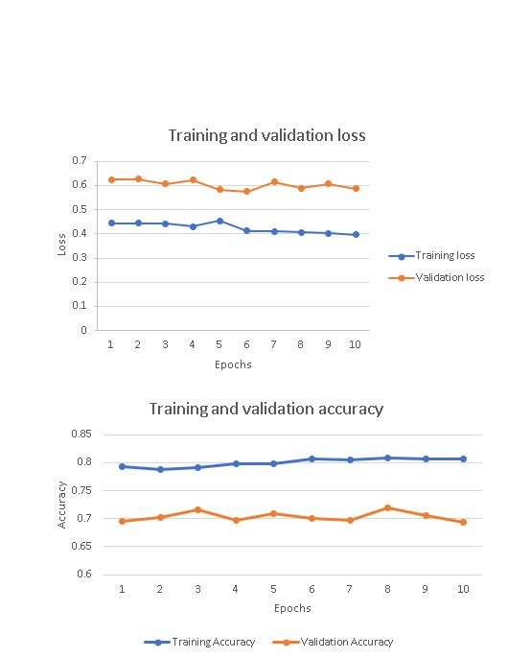

Figure XceptionNet Result

**DenseNet Analysis:** As we can see there is huge difference between training and validation accuracy which means that the model is in overfitting state. By increasing our training dataset size and by using batch normalisation it is possible to prevent our model from going to this condition.

Also, the training accuracy kept on increasing in the final layers whereas validation accuracy stopped improving after 10th epoch. As compared to XceptionNet, the loss in DenseNet is more. Training and Validation Loss did not improve as the training continued. So we feel that XceptionNet, in turn produced better performance.

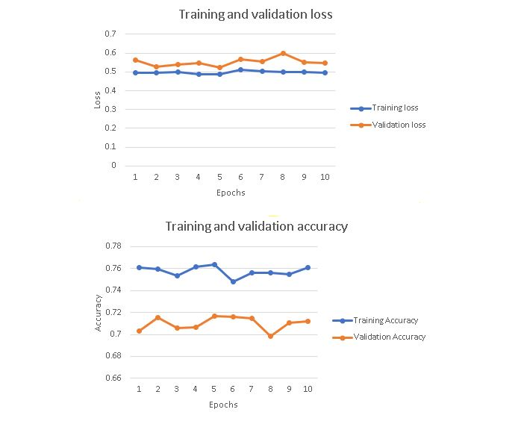

Figure DenseNet result

# Conclusion

The system mentioned is been used properly for deepfake detection . This system is user friendly as it gives the result and this system is easy and any user can access it .We have used MTCNN for pre-processing if the image is not front faced then it focuses to change the coordinates of the face. . For the detection purpose DenseNet and XceptionNet is used for video and image detection respectively as DenseNet can identify differences between two frames. The pre-processing and changing the parameters of the existing model may help increasing the accuracy.For the future purpose the system may work on the larger dataset . This is very economical and maybe easy to use .

# Future Scope

The future work on this project would be :

* Training model on large dataset
* Finding results on tough conditions where there is limited brightness or a person is wearing sunglasses.
* Finding Deepfake from image/video URL
* Deepfake in audio
* Exploring newer technologies in deepfake detection
* Hosting our entire system on AWS/GCP.

# Research Paper

A Review on DeepFake Detection

Ankit Basrur  
Department of Information Technology  
D.J.Sanghvi College of Engineering *Mumbai, India*   
ankit.basrur@djsce.edu.in

Dhrumil Mehta   
Department of Information Technology  
D.J.Sanghvi College of Engineering *Mumbai, India*   
dhrumil.mehta@djsce.edu.in  
Devansh Mehta  
Department of Information Technology  
D.J.Sanghvi College of Engineering *Mumbai, India*   
devansh.mehta1@djsce.edu.in

Vinaya Sawant  
Department of Information Technology  
D.J.Sanghvi College of Engineering *Mumbai, India*   
vinaya.sawant@djsce.ac.in

*Abstract*— Deepfakes are increasingly exponentially which can be a threat to privacy of an individual. Deepfake creation is easily done by layman due to availability in various tools available, which can be used for the defamation of an individual/organization/community. Therefore, different methods have been introduced to address this issue. Early methods were based on the inconsistencies of fake video obtained by using handcrafted features. Recent methods, on the other hand, applies deep learning to automatically extract prominent and discriminatory features to detect deepfakes. This paper shows study related to existing deepfake detection and proposes a technique using various algorithms for images and for videos.

Keywords— Deepfakes, Image Processing, Neural Networks, Machine learning, Deep learning

# INTRODUCTION

The increasing growth of mobile camera technology and social media have creation and sharing of images and videos more convenient. The number of fake images as well as videos are increasing due to high level of editing tools available on Internet. The time required in manipulation of the data available to the person has decreased significantly due to Deepfake creation tools which are easily available. The knowledge of ML and computer vision decreases the manual steps required for image or video editing. This has led to an increase in spreading replicated images and videos (Deepfake). Deepfakes are synthetic media in which a person in an existing image or video is replaced with someone else's likeness.

Convolutional Neural Networks (CNNs) have gained much popularity in recent years for vision-related applications and have the potential to achieve high accuracy. Different type of Generative Adversarial Network (GAN) algorithm is used for creation of fake images, which makes it difficult to differentiate between real and fake images. In this paper, we have used separate architecture for detection of Deepfake in images and for videos. We have used MTCNN for face detection followed by face alignment using dlib. We trained models using different backbone networks, XceptionNet and DenseNet, which can be used for images and videos.

# LITERATURE SURVEY

## *Literature related to Existing System*

• Amber: Amber creates video using by hashing the clips ate source and storing it in blockchain which can be useful for tracking the chain of custody. They have also used detecting splicing artifacts using Neural Network that can detect when a content is added to a video using ResNet and algorithms for finding out facial discrepancies and camera specific signatures and misalignments in color filter array and anomalies in gradients but also detecting post-processing of face swaps which includes Blur Detection and Color Matching. It can be used only on iOS and supports only video detection. A small subscription fee is also charged by the vendor [1].

• TruePic: It is mainly focussed on object verification but the same principle can be used for deepfakes as well. It verifies critical metadata at the point of capture with the one received. It uses blockchain as well as AI to detect manipulations in metadata or objects. It is limited to only those who subscribe to their application and charges fee once the trial is over. It supports both images as well as for videos [2].

## *Literature related to Approaches*

This work reviews the latest techniques and methods that can be used for the detection of Deepfake. The classification of deepfake follows various steps like pre-processing, training, classification. In this paper, each domain is analysed.

### Pre-processing

In pre-processing stage, the video is divided into frames and face detection and alignment is performed on both, images and frames from videos. The scaling of images such that every face can be aligned with same y-coordinates of eyes. It is common step for both images and videos.

#### *Face Detection*

##### HOG face detector using dlib

The Histogram of Oriented Gradients (HOG), which transforms image pixels into a vector representation that is sensitive to broadly informative image features regardless of confounding factors like illumination. HOG face detection is based on Sliding Window Classifier.

After the training dataset is formed, sliding window classifier is used to classify whether there is a face or not in the image using all the HOG represented images. HOG face detector HOG and Convolutional Neural Network (CNN) both are used to detect the face.

It does not work well for non-frontal faces as described in [3]. Deep Learning method is more accurate than HOG, but it requires high computational power like High GPU, CPU, etc. as compared to HOG.

##### Multi-task Cascade Convolutional Neural Network (MTCNN)

MTCNN consists of 3 stages, which detects the bounding boxes of faces in an image along with 5 features of facial landmarks. Each stage passes its inputs to a CNN. Bounding boxes with scores are returned.

The input image is scaled down and is passed through CNN. Image extraction is performed for each bounding box and resize them (24x24 and 48x48 for phase 2 and phase 3, respectively) and are forwarded to CNN. Stage 3 additionally computes 5 features of facial landmarks along with the confidence value [4].

##### Recursive Spatial Transformer (ReST)

It can be used for Face detection and Alignment. The detected face can be transformed to a new one by optimizing an affine transformation using ReST model. From a frame, the ReST model transforms it recursively to make it easier to recognise a face. In each recursion, based on previously transformed face, a transformation is generated to get to the optimal one.

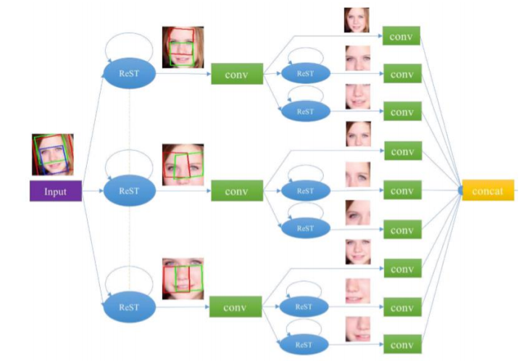

Fig 1. Hierarchical ReST

To model non-linear variations, Hierarchical ReST (HiReST) is an extension to ReST. In HiReST, a face is divided and are used with a ReST which is used to determine rigid area along with its alteration parameters [5].

#### *Face Alignment*

We had to use face alignment to reduce training differences so that our model trains faster and also improve efficiency. Basically, face alignment using OpenCV follows certain steps [8]:

First step is to detect a face and eyes after which centre of eyes is found. Connecting those two points and forming a right-angled triangle will help us in finding the angle. Last step is rotating the image by that angle.



Fig 2. Face Alignment using OpenCV and Python [7]

### *Training*

##### Feature Extraction

Face masks can be used to train model with only specific landmarks of the face. This face masks captures the facial image that contains the inner part of the face [8] [9] [10]. In [8]the mask included areas between eyebrows and mouth and outer part of eyes is scaled down so it fits the input of network whereas in [10] a mask is drawn around the face. It is different in [9], where they have used attention map mechanism which helps to improve the feature map that helps to improve the binary classification. When an image is taken, camera model identification can be found due to high frequency information of the real image [11]. Hence attention map is used to detect the patches within the image which can be further used to differentiate fake images. The patches are then passed to the next layer instead of passing an entire face.

##### Training Model

In some cases, pretrained model gave better accuracy than the model which were trained from scratch. [8] used 4-fold cross validation for separating the training and testing data. They have used pretrained GoogLeNet, VGG19 and AlexNet out of which AlexNet had the lowest False Acceptance Rate (FAR) and False Rejection Rate (FRR) followed by GoogLeNet and AlexNet.

In [12] discovered that using 5 convolutional layers with kernel size to map input to 1x2 output is sufficient. To control the flow, each layer had different kernel size. The input to the model was a 64x64 pixel grayscale image on which the face detection was applied using pretrained HOG and Linear SVM Object Detection. The 5 convolutional layer consists of multiple convolutional and max pooling layers. At the end, they had a flatten layer to convert all the pooling layers in a single column which can then be passed to Dense layer which connects the fully connected layer to the Network. Batch Normalization and dropout layers after each layer reduced the overfitting problem and also increased the performance. AdaBoost classifier was used instead of Softmax which helped the model to perform well.

XceptionNet is also used which detect face swaps in videos and manipulation in images. Both state-of-art methods have used XceptionNet [13] [10]. The 128x128 pixels are trained by using SVM classifier. 5 different methods were compared for detection and XceptionNet with replacement of the final fully connected layer to 2 outputs and proved to be the best network for detection [13]. [10] helps to find whether image is fake or genuine and also highlights the fake portion. They have used Attention Map to detect patches within image and the attention-based layer used sigmoid function. Manipulation Appearance Model (MAM) is a linear combination of sets of map prototype. When calculating loss function, they have used Softmax classifier. For the attention map learning, they have classified it into supervised, weakly supervised and unsupervisedlearning. They a ground truth manipulation mask and the images are sent to pretrained VGG16 and XceptionNet which is modified by inserting attention-based layer between block 4 and 5 networks which are fine-tuned on their dataset.

Training using DenseNet and RNN: The model extracts feature from selected regions of the face and collectively it adds the feature to the backbone network which acts as learner [14].

While Photo Response Non-Uniformity (PRNU) model searches for defects in light sensitive sensors of a camera. Frames from the video are sequentially divided into eight groups of equal size, with the software ’PRNUCompare’. Normalised cross correlation scores are returned after the comparison of 8 PRNU patterns. The variations in correlation and average correlation scores are generated. Welch’s t-test is used to assess the statistical between the results for Deepfakes and for authentic videos i.e. the mean normalised cross correlation scores and the difference in normalised cross correlation scores. A significantly lower score indicates the video has been manipulated [11].

Face masks can be used to train model with only specific landmarks of the face. This face masks captures the facial image that contains the inner part of the face [8] [9] [10]. In [8]the mask included areas between eyebrows and mouth and outer part of eyes is scaled down so it fits the input of network whereas in [10] a mask is drawn around the face. It is different in [9], where they have used attention map mechanism which helps to improve the feature map that helps to improve the binary classification. When an image is taken, camera model identification can be found due to high frequency information of the real image [11]. Hence attention map is used to detect the patches within the image which can be further used to differentiate fake images. The patches are then passed to the next layer instead of passing an entire face.

### *Detection Networks*

#### DensetNet

It is used to extract features at different layers in a network. In this model, each layer can access loss function of the previous layer and the original video signal which helps in improving efficiency. It then concatenates features learned from each layer. Densenet architecture uses of three direction feature extraction: a down-sampling path which is used for extracting coarse semantic features, followed by an up-sampling path to recover the input image resolution at the output of the model and, optionally, a post-processing module to refine the model predictions. At the end of layer, we get a spatiotemporal matrix which consists of features detected from each layer. After face detection, N faces will be obtained and will be sent to network [15]. For learning spatiotemporal information, DenseConvLSTM is employed. Regardless of the results which are obtained, the features can be passed to next structure using Concat. 3D DenseNet is employed for spatiotemporal information fusion. Each convolution block has 3 different layers which connects to ConvLSTM block. It contains two bi-directional LSTM. Using DenseNet architecture with 3D convolutions, all features will be aligned [15].



Fig 3. DenseNet architecture for deepfake detection

#### XceptionNet

Xception is an extension to Inception. It makes use of a pre-trained ResNet18 model on ImageNet, and move the weights is for learning features that are more beneficial for detection i.e. objects, skin colour alteration, distortion, etc. It makes the model to look for more useful features.

Unlike other models where a FC classifier is utilized for facial highlights extraction by ResNet18. For example, eyes or ears, that would just retain certain faces which are linked with the label name “real” while others are linked with the name “fake”. ResNet18 is customized so that it looks for other artifacts such as distortion or discrepancies in a face to detect deepfake, hence can overcome the problems discussed earlier. Due to this, classifier can generalize better for new and untrained deepfakes. Also, classifier architecture which has one or more dense layers are used in place of ResNet18, with hidden activations [16].

Drawbacks: This model cannot detect unique forgery like Neural Textures, as it is not trained on those samples.

#### ResNet

Using a CNN model, comparison is made between the generated face areas and their surrounding regions. ResNet is a customized CNN architecture. ResNet50 is commonly used as it can detect deepfakes better than MesoNet [17].

Align the detected faces into multiple scales and randomly pick one scale, which is then smoothed by a Gaussian blur with kernel size (5x5). This aides in improving the resolution. The face undergoes an affine warp to the same sizes of original faces to simulate the artifacts in the DeepFake production pipeline.To add variety to the training dataset, variations in illumination, contrast, alteration and sharpness for all training examples are made, which can be distinguished by the pipeline [17].

Drawback: The accuracy of this model decreases once 1200 layers are used up.

#### Photo Response Non-Uniformity (PRNU)

Gyfcat is used to spot inconsistencies in the facial area of an uploaded video. When the detection model marks a video suspicious, a facial mask is generated to check whether a video exists with the same body and background. If it exists, but the faces of the original and the newly uploaded video do not match, then the software concludes that the new video has been manipulated [11].



Fig 4 Photo Response Non-Uniformity

Drawback:It requires large databases of videos from which it can compare between the videos.

# PROPOSED SYSTEM ARCHITECTURE



Fig 5 Proposed System

Pre-processing: Initially, if the input is video then it is broken down into frames based on predefined frame rate and then it is converted into greyscale and then MTCNN is used for face detection. Face alignment is applied using OpenCV so that eye level will be the same for all the frames which will be helpful for training the model. Lastly, the input is scaled so as to fit it into the detection model.

* DenseNet: This is a pretrained model which needs to be fine-tuned with our dataset. Since each layer receives an input from all previous layers, it makes feature propagation better and also reduces the parameters.
* XceptionNet: It is a traditional CNN trained on ImageNet based on separable convolutions with residual connections. In this technique we transfer it to our task by replacing the final fully connected layer with two outputs.
* Attention Based Model: This model was introduced for Natural Language Processing (NLP) tasks. It gives attention to several salient feature, which will be passed ahead in the network. It is the most suitable model since it will highlight the region that has discrepancies in it, rather than focusing on entire image. This will help to learn salient features and it will eventually increase accuracy and speed.
* Classifier: Softmax can be used as binary classifier to classify whether an image is fake or genuine.
* Dataset: On Kaggle they have provided entire dataset compressed into one single zip file called all.zip which is 471 GB in size and the same zip file is split into 50 chunks of separate zip files, each 10 GB in size. Diverse Fake Faces Dataset (DFFD) for pristine fake images, it has around 1.8M fake and 0.8M real images.

# OBSERVATIONS

Table 17 Review on techniques used in various research paper

|  |  |  |  |  |
| --- | --- | --- | --- | --- |
| **Sr. no.** | **Paper name** | **Dataset** | **Algorithm** | **Type** |
| 1 | Detection of Face Morphing Attacks by Deep Learning [8] | ILSVRC dataset 9000 fake images | VGG-19, GoogleNet | Images |
| 2 | Face X-ray for More General Face Forgery Detection [9] | FaceForensics++ having 1000 videos (Real and fake) | Face X-ray | Images |
| 3 | On the Detection of Digital Face Manipulation [10] | Video dataset from FaceForensics++, FaceAPP images from StyleGAN and PGGAN | Xceptionet | Images and videos |
| 4 | Deep Learning Based Computer-Generated Face Identification Using Convolutional Neural Network [12] | PCGAN and BEGAN dataset | CGFace (customized CNN) | Images |
| 5 | FaceForensics++: Learning to Detect Manipulated Facial Images [13] | Dataset provided by Google and JigSaw | Xceptionnet | Images and videos |
| 6 | Recurrent Convolutional Strategies for Face Manipulation Detection in Videos [14] | FaceForencsice++ dataset 1000 videos (Real and fake) | RCN and DenseNet | Videos |
| 7 | Detection of Deepfake Video Manipulation [11] | Custom made dataset | PRNU | Videos |
| 8 | Deep Learning with Depthwise Separable Convolutions [16] | Xceptionet ImageNet and JFT (Google dataset) | XceptionNet | Images |

##### CONCLUSION

The report gives an analysis of diverse systems, their approaches and methodologies, algorithms, technologies that have been used earlier. This review paper is demonstrating a comparative study between them, understanding their efficiencies, their merits and demerits. After having the detailed analysis, the paper also proposed an improved plan for differentiating between real and fake by comparing different ways to detect face manipulations for both images and videos. The pre-processing and changing the parameters of the existing model may help increasing the accuracy. This review paper helps us in understanding the basic building block of the system that we would be developing in future.

##### REFERENCES

|  |  |
| --- | --- |
| [1] | "Amber: fake video solved.," Amber, [Online]. Available: https://ambervideo.co/. [Accessed 17 September 2020]. |
| [2] | "Truepic | Truepic Vision," [Online]. Available: https://truepic.com/truepic-vision/. [Accessed 17 September 2020]. |
| [3] | sukeshroy, "Face Detection and Recognition Using OpenCV," [Online]. Available: https://www.datasciencelearner.com/face-detection-recognition-python-hog-tutorial/. [Accessed 7 August 2020]. |
| [4] | J. Brownlee, "How to Perform Face Detection with Deep Learning," [Online]. Available: https://machinelearningmastery.com/how-to-perform-face-detection-with-classical-and-deep-learning-methods-in-python-with-keras/. [Accessed 19 August 2020]. |
| [5] | W. Wu, M. Kan, X. Liu, Y. Yang, S. Shan and X. Chen, "Recursive Spatial Transformer (ReST) for Alignment-Free Face Recognition," *2017 IEEE International Conference on Computer Vision (ICCV),* no. October 2017, pp. 3792-3800, 2017. |
| [6] | V. Kovenko, "How to precisely align face in Python with OpenCv and Dlib," Towards Data Science, 11 August 2019. [Online]. Available: https://towardsdatascience.com/precise-face-alignment-with-opencv-dlib-e6c8acead262. [Accessed 26 AUgust 2020]. |
| [7] | datahacker.rs, "How to align faces with OpenCV in Python," 10 June 2020. [Online]. Available: http://datahacker.rs/010-how-to-align-faces-with-opencv-in-python/. [Accessed 20 September 2020]. |
| [8] | C. Seibold, W. Samek, A. Hilsmann and P. Eisert, "Detection of Face Morphing Attacks by Deep Learning," *Digital Forensics and Watermarking,* pp. 107-120, 26 July 2017. |
| [9] | L. Li, J. Bao, T. Zhang, H. Yang, D. Chen, F. Wen and B. Guo, "Face X-ray for More General Face Forgery Detection," *arXiv CVPR 2020,* vol. 2, 19 April 2020. |
| [10] | H. Dang, F. Liu, J. Stehouwer, X. Liu and A. Jain, "On the Detection of Digital Face Manipulation," *In Proceeding of IEEE Computer Vision and Pattern Recognition (CVPR 2020),* vol. 4, 19 April 2020. |
| [11] | M. Koopman, A. M. Rodriguez and Z. Geradts, "Detection of Deepfake Video Manipulation," *Proceedings of the 20th Irish Machine Vision and Image Processing conference,* 20 8 2018. |
| [12] | L. Dang, S. Hassan, S. Im, J. Lee, S. Lee and H. Moon, "Deep Learning Based Computer Generated Face Identification Using Convolutional Neural Network," *Applied Sciences,* vol. 8, no. 12, p. 2610, 2018. |
| [13] | A. Rossler, D. Cozzolino, L. Verdoliva, C. Riess, J. Thies and M. Niessner, "FaceForensics++: Learning to Detect Manipulated Facial Images," *2019 IEEE/CVF International Conference on Computer Vision (ICCV),* 2019. |
| [14] | E. Sabir, J. Cheng, A. Jaiswal, W. AbdAlmageed, I. Masi and P. Natarajan, "Recurrent Convolutional Strategies for Face Manipulation Detection in Videos," *arXiv,* 16 May 2019. |
| [15] | G. Huang, Z. Liu, L. v. d. Maaten and K. Q. Weinberger, "Densely Connected Convolutional Networks," *arXiv CVPR 2017,* vol. 5, 2018. |
| [16] | F. Chollet, "Xception: Deep Learning with Depthwise Separable Convolutions," *2017 IEEE Conference on Computer Vision and Pattern Recognition (CVPR),* 2017. |
| [17] | Y. Li and S. Lyu, "Exposing DeepFake Videos By Detecting Face Warping Artifact," *CVPRW 2019,* vol. 3, 22 May 2019. |

*Detection of Image and Video Manipulation*

Ankit Basrur   
Information Technology  
Dwarkadas J. Sanghvi College of EngineeringMumbai,India  
ankit.basrur@djsce.edu.in

Dr. Vinaya Sawant   
HOD of Information Technology  
Dwarkadas J. Sanghvi College of EngineeringMumbai,India  
vinaya.sawant@djsce.ac.in

Devansh Mehta   
Information Technology  
Dwarkadas J. Sanghvi College of EngineeringMumbai,India  
devansh.mehta1@djsce.edu.in

Dhrumil Mehta  
Information Technology  
Dwarkadas J. Sanghvi College of EngineeringMumbai,India  
dhrumil.mehta@djsce.edu.in

*Abstract*— Deepfakes are increasingly exponentially which can be a threat to privacy of an individual. Deepfake creation is easily done by layman due to availability in various tools available, which can be used for the defamation of an individual/organization/community. Therefore, different methods have been introduced to address this issue. Early methods were based on the inconsistencies of fake video obtained by using handcrafted features. Recent methods, on the other hand, applies deep learning to automatically extract prominent and discriminatory features to detect deepfakes. This paper proposes detecting Deepfake using XceptionNet and DenseNet for images and videos respectively.

Keywords— Deepfake Detection, Image Processing, Neural Networks, Machine learning, Deep learning.

# Introduction

The increasing growth of mobile camera technology and social media have creation and sharing of images and videos more convenient. The number of fake images as well as videos are increasing due to high level of editing tools available on Internet. The time required in manipulation of the data available to the person has decreased significantly due to Deepfake creation tools which are easily available. The knowledge of ML and computer vision decreases the manual steps required for image or video editing. This has led to an increase in spreading replicated images and videos (Deepfake). Deepfakes are synthetic media in which a person in an existing image or video is replaced with someone else's likeness.

Convolutional Neural Networks (CNNs) have gained much popularity in recent years for vision-related applications and have the potential to achieve high accuracy. Different type of Generative Adversarial Network (GAN) algorithm is used for creation of fake images, which makes it difficult to differentiate between real and fake images. In this paper, we have used separate architecture for detection of Deepfake in images and for videos. We have used MTCNN for face detection followed by face alignment using dlib. We trained models using different backbone networks, XceptionNet and DenseNet, which can be used for images and videos.

# Scope

This system is generally user friendly as the user only has to upload image/video files and this will also be feasible to use on laptop as well as your smartphones. The solution is basically based on the detection of the images and videos and is based on two Algorithms that will give the user results of detection at the end of the process based on the fake probability. The image will first be checked that if the file will be able to upload, if yes then the process will go forward else the message will be shown that the file is not detected. Each step of this process have a significance in itself as for pre-processing the images will be first aligned by aligning the eyes of the person and then going through some parameters the system will go through the algorithm .At the end of process the system will give the result and it will give fake probability and if the result says that the image is real it does not go through frame by frame distribution. If the image is fake then the user can go through the next step where the probability of the image being fake is given for a person .

# Proposed system design

Since deepfakes can be easily generated, it becomes essential to stop inappropriate news from spreading which can cause a huge damage. Hence, a novel and helpful way to deal with detection of low- and high-quality pictures utilizing profound learning methods is recommended. An image or video is taken as input from user in real time. The proposed arrangement would be a web application/online interface. The utilization of neural networks and image processing is illustrated. Processed media is then sent to our networks depending upon its type and the results are shows on each frame as output.

Fig. 1. below is the system architecture of our proposed system. It includes abstract relations with proposed features.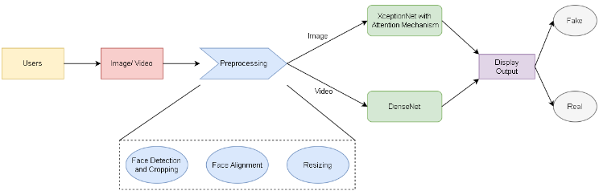

1. System Architecture

In the first stage, we convert video into sequence of frames. Our aim was to find all faces in a given frame. Post that, we subjected the images to some preprocessing algorithms such as MTCNN and dlib.

After initial preprocessing of all images, feature extraction and deep feature learning is performed. At the end of our network, we have used sigmoid function which get a number between 0 and 1 for each output.

# Dataset

Our dataset is a subset of DFFD dataset. It is mainly classified into fake and real. The dataset consists of over 12,000 images in the train set and 6000 images in the test set. Each image is subject to preprocessing, deep feature learning and extraction, and image classification. These images are of high quality and pristine. Making our model train on such dataset can be helpful when input cannot be easily distinguished. Each image goes through the above-mentioned stages, and at each stage, the output after the process is displayed.

# Implementation:

## Image Preprocessing

The preprocessing step includes Face Detection, alignment and rescaling it. Various algorithms were implemented to find the best fit for our system. For Face Detection the following algorithms were implemented, Histogram of Oriented Gradients (HOG) and Multitask Cascade Convolutional Neural Network (MTCNN).

* **Histogram of Oriented Gradients (HOG)**: HOG uses Haar Cascade Classifier for detecting and then cropping the face region out of the given input. This face detection is based on Sliding Window Classifier. A geometric face region is formed with the detection of eyes performed using the Haar Cascade Classifier, while nose detection has been used as a confirmation tool with the detection of eyes. It does not work well for non-frontal faces as described in [1].
* **Multitask Cascade Convolutional Neural Network (MTCNN)**: MTCNN is a neural network which detects faces and facial landmarks on images. It is relatively newer method of face detection. This technique consists of 3 neural networks which are connected in cascade, first detects the bounding boxes of faces in an image along with 5 features of facial landmarks. Each NN passes its inputs to a CNN. Bounding boxes with scores are returned. In the final stage, it computes 5 features of facial landmarks along with the confidence value [2]. MTCNN is highly accurate for detecting non-frontal faces making it ideal for our use case.

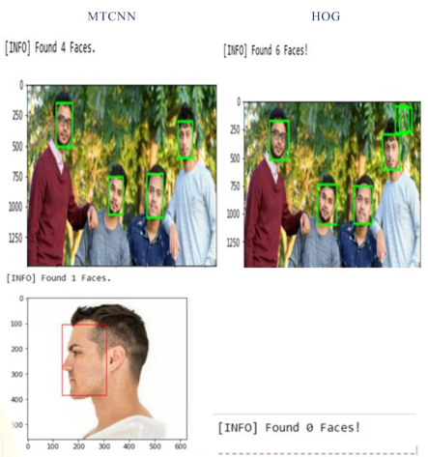

1. *Image subjected to various processing methods*

Face alignment is an important process to reduce irregularities so that our model is consistent and trains faster. We have used OpenCV and dLib for getting the coordinates of eyes and nose. It consists of following steps [3]: Initially we have to detect the face and eyes after which centre of eyes is found. Connecting those two points and forming a right-angled triangle will help us in finding the angle. The last step is rotating the image by that angle using OpenCV.

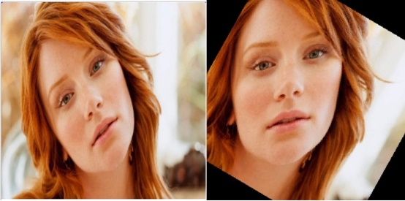

Fig. 3. *Face Alignment using OpenCV*

Table 18 *Face detection models*

|  |  |  |  |  |
| --- | --- | --- | --- | --- |
| **Model name** | **Method** | **Bounding Box Shape** | **Time** | **Downsides** |
| HOG | Sliding window classifier | Square | Least | Bounding box always a square which leads to over high lightening of region.  Cannot detect non-frontal faces |
| MTCNN | Cascade of Neural Networks | Arbitrary rectangle | Highest | Consist of 3 neural networks thus takes more time. |

## Classification

* **XceptionNet with Attention Mechanism:** XceptionNet is a neural network which uses residual connections and is pretrained on ImageNet, fine-tuned on our dataset. It moves the weights for learning features that are more beneficial for detection i.e., objects, skin color alteration, distortion, etc [4][5]. XceptionNet with replacement of the final fully connected layer to 2 outputs and proved to be the best network for detection. We chose XceptionNet because it has two advantages: It makes the model to look for more useful features. Second, using it along with Attention Map to detect patches within image and the attention-based layer used sigmoid function. The dimension of input image was changed so that it fits the input of our network i.e. 299 x 299. We generate face mask using the features obtained in the earlier layer which helps model to learn in a better manner. XceptionNet with replacement of the final fully connected layer to 2 outputs and proved to be the best network for detection [4] and then adding Attention Model between block 4 and 5 in XceptionNet for better results.
* **DenseNet:** DenseNet became popular because of efficient back-propagation and concept of concatenating to reduce the size of feature map for deeper layers [6][7]. It consists of Batch Normalization, DenseBlock and Transition Layer. It extracts feature from selected regions of the face and collectively it adds the feature to the backbone network which acts as learner [7]. It reduces the number of parameters to be passed to the next layer and each layer has access to gradients from loss function which helps in better back propagation. We have changed the input size to 224x224. After which we freeze the initial layers of network during training. Training of network was divided into two parts viz., freezing the initial layer for 10 epochs and unfreezing and training the final layers for 5 epochs. It was observed that the training speed for DenseNet was much faster than that of XceptionNet.

Both the networks were trained for 15 epochs using Adam optimizer with learning rate as 1e-4 with an early stopping condition to avoid overfitting.

When a new image is fed into the model for the prediction it gives the results in the probabilistic results. The study was based on a dataset that included 18000 images.

# Experimental results

* **XceptionNet Analysis:** On analysis we found out that the accuracy of XceptionNet and DenseNet is almost same. The reason being the size of our dataset which was comparatively less for neural network to learn new features. In the last few epochs the training and validation accuracy did not improve which means model lost it's ability to distinguish between real and fake image after being trained again and again on the same dataset. The validation loss decreased in the final epoch.



1. Training Loss and Accuracy for XceptionNet

* **DenseNet Analysis:** As we can see there is huge difference between training and validation accuracy which means that the model is in overfitting state. By increasing our training dataset size and by using batch normalisation it is possible to prevent our model from going to this condition.

Also, the training accuracy kept on increasing in the final layers whereas validation accuracy stopped improving after 10th epoch. As compared to XceptionNet, the loss in DenseNet is more. Training and Validation Loss did not improve as the training continued. So we feel that XceptionNet, in turn produced better performance.



1. Training Loss and Accuracy for DenseNet

# Conclusion

The proposed system is significantly useful for detecting deepfake. The presented system is accurate, efficient, low cost, portable and user friendly so that any user can access it. Based on our study we have used MTCNN for pre-processing

as it is capable to detect non-frontal faces. For the detection purpose DenseNet and XceptionNet is used for video and image detection respectively as DenseNet can identify differences between two frames. In future, the system can be improved by training on larger dataset and to reduce false positive ratios.

After studying and analyzing different algorithms similar to our project we conclude that it is possible to implement this project. And from technical, operational and economic feasibilities we can conclude that the system is possible to implement.

# Future Scope

We are currently trying to run this model on a bigger dataset which may help in improving efficiency of our model. The detection is based on the discrepancies found on single frame but we did not detect the alignment of audio with input video. Detecting on the basis of audio and training our model on a larger dataset can be helpful in understanding more about ways in which DeepFake can be detected.

**References**

1. sukeshroy, “Face Detection and Recognition Using OpenCV,” [Online]. Available: https://www.datasciencelearner.com/face-detection-recognition-python-hog-tutorial/. [Accessed 7 August 2020].
2. K. Zhang, Z. Zhang, Z. Li and Y. Qiao, "Joint Face Detection and Alignment using Multi-task Cascaded Convolutional Networks," *IEEE,* 2016.
3. V. Kovenko, "How to precisely align face in Python with OpenCv and Dlib," Towards Data Science, 11 August 2019. [Online]. Available: https://towardsdatascience.com/precise-face-alignment-with-opencv-dlib-e6c8acead262. [Accessed 26 August 2020].
4. A. Rossler, D. Cozzolino, L. Verdoliva, C. Riess, J. Thies and M. Niessner, "FaceForensics++: Learning to Detect Manipulated Facial Images," *2019 IEEE/CVF International Conference on Computer Vision (ICCV),* 2019.
5. M. Koopman, A. M. Rodriguez and Z. Geradts, "Detection of Deepfake Video Manipulation," Proceedings of the 20th Irish Machine Vision and Image Processing conference, 20 8 2018.
6. G. Huang, Z. Liu, L. v. d. Maaten and K. Q. Weinberger, "Densely Connected Convolutional Networks," *arXiv CVPR 2017,* vol. 5, 2018.
7. E. Sabir, J. Cheng, A. Jaiswal, W. AbdAlmageed, I. Masi and P. Natarajan, "Recurrent Convolutional Strategies for Face Manipulation Detection in Videos," arXiv, 16 May 2019.

# References

|  |  |
| --- | --- |
| [1] | “Amber: fake video solved.,” Amber, [Online]. Available: https://ambervideo.co/. [Accessed 17 September 2020]. |
| [2] | “Truepic | Truepic Vision,” [Online]. Available: https://truepic.com/truepic-vision/. [Accessed 17 September 2020]. |
| [3] | sukeshroy, “Face Detection and Recognition Using OpenCV,” [Online]. Available: https://www.datasciencelearner.com/face-detection-recognition-python-hog-tutorial/. [Accessed 7 August 2020]. |
| [4] | J. Brownlee, “How to Perform Face Detection with Deep Learning,” [Online]. Available: https://machinelearningmastery.com/how-to-perform-face-detection-with-classical-and-deep-learning-methods-in-python-with-keras/. [Accessed 19 August 2020]. |
| [5] | W. Wu, M. Kan, X. Liu, Y. Yang, S. Shan and X. Chen, “Recursive Spatial Transformer (ReST) for Alignment-Free Face Recognition,” *2017 IEEE International Conference on Computer Vision (ICCV),* no. October 2017, pp. 3792-3800, 2017. |
| [6] | “Brightness Adjustment,” [Online]. Available: https://stackoverflow.com/questions/57030125/automatically-adjusting-brightness-of-image-with-opencv. |
| [7] | A. Rosebrock, “Face Detection with Opencv and Deep Learning,” 26 February 2018. [Online]. Available: https://www.pyimagesearch.com/2018/02/26/face-detection-with-opencv-and-deep-learning/. |
| [8] | V. Kovenko, “How to precisely align face in Python with OpenCv and Dlib,” Towards Data Science, 11 August 2019. [Online]. Available: https://towardsdatascience.com/precise-face-alignment-with-opencv-dlib-e6c8acead262. [Accessed 26 AUgust 2020]. |
| [9] | G. Huang, Z. Liu, L. v. d. Maaten and K. Q. Weinberger, “Densely Connected Convolutional Networks,” *arXiv CVPR 2017,* vol. 5, 2018. |
| [10] | F. Chollet, “Xception: Deep Learning with Depthwise Separable Convolutions,” *2017 IEEE Conference on Computer Vision and Pattern Recognition (CVPR),* 2017. |
| [11] | Y. Li and S. Lyu, “Exposing DeepFake Videos By Detecting Face Warping Artifact,” *CVPRW 2019,* vol. 3, 22 May 2019. |
| [12] | M. Koopman, A. M. Rodriguez and Z. Geradts, “Detection of Deepfake Video Manipulation,” *Proceedings of the 20th Irish Machine Vision and Image Processing conference,* 20 8 2018. |
| [13] | A. Rossler, D. Cozzolino, L. Verdoliva, C. Riess, J. Thies and M. Niessner, “FaceForensics++: Learning to Detect Manipulated Facial Images,” *2019 IEEE/CVF International Conference on Computer Vision (ICCV),* 2019. |
| [14] | D. Guera and E. Delp, “Deepfake Video Detection Using Recurrent Neural Networks,” *2018 15th IEEE International Conference on Advanced Video and Signal Based Surveillance (AVSS),* pp. 1-6, November 2018. |
| [15] | L. M. Dang, S. Hassan, S. Im, J. Lee, S. Lee and H. Moon, “Deep Learning Based Computer Generated Face Identification Using Convolutional Neural Network,” *Applied Sciences,* vol. 8, 13 December 2018. |
| [16] | C. Seibold, W. Samek, A. Hilsmann and P. Eisert, “Detection of Face Morphing Attacks by Deep Learning,” *Digital Forensics and Watermarking,* pp. 107-120, 26 July 2017. |
| [17] | L. Li, J. Bao, T. Zhang, H. Yang, D. Chen, F. Wen and B. Guo, “Face X-ray for More General Face Forgery Detection,” *arXiv CVPR 2020,* vol. 2, 19 April 2020. |
| [18] | H. Dang, F. Liu, J. Stehouwer, X. Liu and A. Jain, “On the Detection of Digital Face Manipulation,” *In Proceeding of IEEE Computer Vision and Pattern Recognition (CVPR 2020),* vol. 4, 19 April 2020. |
| [19] | L. Dang, S. Hassan, S. Im, J. Lee, S. Lee and H. Moon, “Deep Learning Based Computer Generated Face Identification Using Convolutional Neural Network,” *Applied Sciences,* vol. 8, no. 12, p. 2610, 2018. |
| [20] | E. Sabir, J. Cheng, A. Jaiswal, W. AbdAlmageed, I. Masi and P. Natarajan, “Recurrent Convolutional Strategies for Face Manipulation Detection in Videos,” *arXiv,* 16 May 2019. |
| [21] | datahacker.rs, “How to align faces with OpenCV in Python,” 10 June 2020. [Online]. Available: http://datahacker.rs/010-how-to-align-faces-with-opencv-in-python/. [Accessed 20 September 2020]. |
| [22] | V. Kovenko, “How to precisely align face in Python with OpenCv and Dlib,” Towards Data Science, 11 August 2019. [Online]. Available: https://towardsdatascience.com/precise-face-alignment-with-opencv-dlib-e6c8acead262. [Accessed 26 August 2020]. |